Frederick Dalton (1815-1880): Uncovering a Life in Gold
by Brendan Dalton
Abstract
Family historians have long known the usefulness of Trove and biographers are also realizing its value. In this article, Brendan Dalton knew the name of his grandfather, Frederick Dalton but Trove facilitated his contextualizing his grandfather’s life on the goldfields as a traveller on the goldrush circuits, gold prospector, journalist and social commentator, geologist, gold commissioner and goldfields police magistrate. There are 33 gold commissioners, 13 gold prospectors, and 216 mentions of police magistrates in theAustralian Dictionary of Biography and this article contextualizes these occupational groups. More than this, ‘Dalton’s life and work provide insights into some significant and little discussed questions of Australian history and culture’, offering ‘insights into the formation of the public service, government attitudes to science, the development of the mining industry and the responsibility of the state for education’.
My father died in 1997 at 70. He had grown up without a father. In 1927, a few months after my father’s birth, my grandfather Herbert Arthur Dalton died. The male influences in my father’s early life were his maternal uncles – the Leonards – and the Christian Brothers. He grew up with a very strong sense of his own personal history, as fundamentally Irish Australian, Catholic, working class, and in spite of his name, as a Leonard. Dalton being a fairly common Irish name, he assumed that his father’s family had the same background. For my father there was pride in this ancestry; pride based in the love he felt for the unpretentious, deeply religious, funny, heroic (the First World War being a very big part of his family story) and loving people, the aunts and uncles that he had known. While he may have been comfortable with this story, my father felt its contradictions, at times deeply.
We have one photograph of my Dalton grandfather, bending to reward a happy and well trained dog; an Airedale. The man is already 50, tall, in a dark suit and moustachioed in the style of Henry Lawson. The man’s look, like Lawson’s, is almost stereotypically ‘Australian’ from the period before World War I. His look could not be more different to the big eared, long faces and shorter statures of the Leonard males. I have known this photograph all my life and I also know that my father rarely looked at it. Perhaps the mystery of his father was too great and the need to know more too profoundly insatiable.
Apart from the photograph, my father knew some facts of his father’s life; that he had worked for the financier and company director Sir John Garvin; that he had managed Garvin’s rural properties and had trained his polo ponies. My grandmother was in service in one of the Garvin households where the two had met, and in 1922, married– my grandfather was 47, and grandma, Barbara Catherine Leonard, was 23. As a small boy my father said that he had once met one of his Dalton aunts, an encounter not fondly recalled with a tall woman dressed in black; the encounter had scared him. He knew a very little about his grandparents, namely that his grandfather, Frederick, had some official position at Forbes and that there may have been an obituary in a Sydney newspaper.
In the mid-1980s my father suffered from several serious medical conditions. A discussion with my doctor about family medical history led me to realise how little I knew about the Daltons. So, on a cold, grey, Canberra day in July, seeking shelter in the National Library of Australia, I talked to a librarian about the meagre scraps of information I had on my great grandfather, Frederick Dalton. I was able to browse the stacks for the thick blue volumes of the New South Wales Police Gazettes. Within 20 minutes, references began to appear; to appointments as a gold commissioner, police magistrate and warden in places like Uralla (1860), Nundle (1864), Forbes and Grenfell (1867 and beyond). On a later visit, the librarians took me to the micro film readers to review issues of the Sydney Morning Herald. If you have experience in searching through an unindexed 19th century newspaper on a micro film reader, you will know how headache inducing it is to search for one name. Amongst the jumble of news, and editorials and obituaries, no reference appeared to Frederick Dalton. But, amongst the advertising from January 1881, a large government notice stood out, seeking information on the whereabouts of a Mr Frederick Dalton Esq. Police Magistrate, Forbes.
The revelation of my great grandfather’s disappearance was shocking: a senior official late in his career vanishing without a trace. For his family in 1880 his disappearance must have been devastating. Combined with my grandfather’s late marriage and relatively early death, his disappearance also provided a possible explanation for our lack of knowledge about our Dalton relations. The information suggested there was more to be discovered, but I still had little understanding about what a gold commissioner, police magistrate or warden was, or about Frederick Dalton’s life. That is where my research may have stayed. But in 2012 a professional interest in technology, and a suggestion from my eldest brother, led to the historic newspapers searchable through the NLA’s Trove web portal. Entering details relevant to what I knew of Dalton’s life, I began to uncover more detail than I had imagined existed, not just his appointments and promotions, but information about his career, his family, and eventually his thoughts and the views of the communities he worked in. Equally importantly, I was able to identify a series of articles in the Sydney Morning Herald as almost certainly the work of Fredrick Dalton.[1]
A dinner at Grenfell
Grenfell is a township 350 kilometres south west of Sydney. Proclaimed on 1 January 1867, by the next year it was a settled and prosperous community of several thousand citizens. During its first decade it had contributed millions of pounds to the wealth of the colony. The town’s foundation, wealth and population all sprang from gold. The town was situated on the site of the original gold diggings astride Emu Creek, a few kilometres north east of the Weddin Mountains. Europeans had settled the area in the late 1830s establishing a few large sheep stations.[2] The area continued to be home to Aboriginal people as it had for tens of thousands of years, but by 1877 their presence was recorded only in newspaper reports of proceedings in the magistrate’s court.
At 9 pm on Monday 11 June 1877 a banquet was held in the town to inaugurate the new court of quarter sessions and to welcome its new judge.[3] For the town in its tenth year, it was also a coming of age celebration. A local journalist described the festivities:
There were roast turkey, duck, fowl, tongue, with vegetables, including green peas. There were vases filled with fragrant flowers as ornament…There was every variety of puddings, tarts, custards, jellies, oranges, apples, pears, muscatels, and nuts. Nor should we omit to mention the abundance and excellence of the wines, spirits, ale and porter, and the superior manner in which everything was served. In each department all was of the best class, and the wants of the guests were anticipated by the alacrity and care of a numerous and skilful body of attendants.[4]
Presiding over the feast, as chairman of the welcoming banquet, was the Police Magistrate Mr Frederick Dalton Esq. At 62 he was already suffering the consequences of a hard life, with years spent working on goldfields and camping out in the bush on several continents. He had been associated with Grenfell from its beginning. He described his first night in the area in November 1866:
It was then so much of a wilderness that [I] had some difficulty in finding the locality of the, goldfield. Literally there was no road to it. Upon [my] arrival [I] managed to obtain shelter for a night under a sheet of bark.[5]
The Weddin, or Emu Creek, rush was big, and the government, after more than a decade of rushes, was quick to see the need to bring order to the field. So Dalton, an experienced gold commissioner and police magistrate, was ordered to station himself on the new goldfield. There is no record of how he spent his second night on the field, most likely he gave up his sheet of bark for a tent and quickly had an area of the field marked out for his official residence on what became known as Camp Hill. In December he was briefly joined by the gold commissioner from Forbes, 20 miles to the north, who reported favourably on the field and quickly left.[6] A surveyor had also been sent and his energies ensured the basic street plan of the town of Grenfell had been laid out before the end of 1866. These were temporary visitors; Dalton’s job was to stay.
A journalist from Bathurst visited in January 1867 and described the goldfield at the height of its first summer, with a population of over 5,000 diggers:
… a cloud of dust was hovering over the town as if from some mighty conflagration… dust was omnipotent and … accompanied… by a fiery sun and strong wind… things the reverse of pleasing or delightful…[7]
The noise of mining operations was incessant. In the early days a rush site was a place of intense physical activity, with miners digging and sometimes blasting through rock often only a few feet from where they slept. Amidst the maelstrom the new boom town was forming.
The town of Grenfell extends some two miles already, and is hourly lengthening at each end… in it are situated the principal buildings, the two banks… upwards of forty public houses … all licensed, some built of iron, some of weatherboards, some of bark, while others are composed of all three together, and some even consist of a few poles held together by stout calico.[8]
Frederick Dalton Esq; a biography
Frederick Dalton had been a world traveller, digger, social commentator, columnist, geologist and goldfields magistrate. An influential public figure, his activities were well documented in the newspapers and official journals of his time. The lives of many of his friends and colleagues are recorded in the Australian Dictionary of Biography, but fate and the nature of his contribution to early Australian public life, meant that his life and work had been largely forgotten. In 1872 in evidence to the NSW Royal Commission into the regulation of gold mining, Dalton (then a goldfields magistrate of over ten years standing), stated that he arrived in the colony in 1853. Mr Robert Masterton Vaughn, Justice of the Peace at Grenfell and soon to be member of the NSW Legislative Assembly, was vice chairman of the banquet on that winter night in 1877. In one of his several speeches he recalled: …
how strangely things came about in this world, … he first met their worthy Chairman, Mr Dalton, many years ago, when crossing the plains from the Atlantic to the Pacific, in the States of America, both then on their way to another land of gold and excitement.[9]
That Dalton came to Australia from California is corroborated by Vaughn and others, but little else is certain about his early life. He claimed to have been born in Edinburgh in 1815, his father Colonel Tudor Dalton. His later writings suggest that he had been educated in Scotland and that he was well-read. He seems to have had a deep knowledge of literature, history, science, economics and theology. His knowledge of theoretical and practical geology at a time when the science was in its infancy suggests training, but no evidence for this has been found. It is also possible that, as well as the United States, he travelled throughout the United Kingdom and Europe.
He had crossed the Pacific to Sydney after spending time in the heart of the continental US. He wrote:
In the year 1852 I travelled through the Utah territory, situated in the heart of the great American desert, 1200 miles from the nearest abode of civilized man.[10]
Dalton called himself a settler in the US and his writings suggest he had been there and in Canada for some years before his journey to California. He may have held some kind of official position in California in relation to gold, or he may have been there simply as a digger. Dalton admired but was also critical of the US, in particular ‘the insecurity of life and property; the ordeal of blood, anarchy, and confusion that every State founded by the American Union has passed through.’[11]This criticism of the American frontier may have had a personal element. In reminiscences he was described on several occasions as having a malformed or wry neck. In at least one account this was attributed to him having run afoul of the lynch mob in California, which made a good story, but his wry neck may have also been caused by one of many riding accidents. We know that Dalton had a very personal experience of frontier lawlessness. He describes being caught up in frontier tensions in the Utah Territory where, ‘my being mistaken for a Yankee nearly cost me my life, proving myself an Englishman saved it.’[12]
In 1852 news of the discovery of gold in NSW reached the west coast of America, and by 1853 Dalton was in Sydney. Between 1853 and 1858 he tried his luck in search of gold on the Victorian fields, in northern NSW and in southern Queensland. In the late 1850s he was in northern NSW. In all likelihood he is the Mr Dalton described as one of the discoverers of the diggings at Fairfield not far from Tabulam.[13]
In 1856 he married Rosa Lavinia Wood; he was 41 and she was 18. In 1858, their first child was born at Tabulam and Dalton recorded his profession on the birth certificate as ‘farmer’. He may have tried farming after some success as a prospector. His intimacy with the problems faced by ‘new chum’ farmers attempting to replicate modern ‘scientific’ farming techniques in the bush is reflected in one of his SMH columns;
A saying … current both in the Canadas and the Western States, that the “emigrant capitalist farmer must first be ruined before he can succeed," and experience justifies the assertion.[14]
His next decision in mid-1858 was to leave hearth and home for two years as, opting for a steady income but often a bed under the stars, he took on the job of a goldfields columnist for the SMH. His first column was a description of the ‘Western Road’ out of Sydney and over the Blue Mountains to the western goldfields; the settlements along the way, the geology and appearance of the landscape, the engineering of the roads, its bridges and the mountain passes. From the start he commented on NSW society as he found it and as he thought it could be.
Dalton seems to have stayed on the goldfields of the western slopes of the Great Dividing Range for almost a year. In his articles, collectively titled ‘A Visit to the Western Goldfields’, he travels up the water courses talking to diggers, describing their habitations, the sites of rushes and former rushes, the towns that are beginning to be established and the different characteristics of the Chinese, Australian born, European and American diggers. The articles provide detailed descriptions of the geology and geography of the gold bearing regions, information on what the digger will find there, and the prospects for gold, based on the author’s geological analysis.
Dalton the journalist
During 1859 Dalton travelled south to the foothills of the Snowy Mountains and the gold town of Adelong, writing a series entitled ‘A Visit to the Southern Goldfields’. In his final series, ‘A Visit to the Northern Goldfields’, Dalton travelled up the Clarence river to the northern gold fields, Tabulam and beyond almost to the Queensland border, ending in early 1860, the last article posted from Uralla in northern NSW. SMH columnists rarely received attribution, and Dalton’s authorship of these articles went unrecognised until 2014, but not in his life time. Dalton’s articles provide a geological commentary on the goldfields of NSW. There are regular references to his writing and work as a geologist of gold, in the newspapers for the decade after his columns appeared. His views on gold in quartz from the goldfield at Adelong were quoted by the Reverend W. B. Clarke (sometimes styled the father of Australian science) in his 1860 book Researches on the Goldfields of Southern Australia.[15] The gold rushes were mass movements of diggers, informed mainly by rumour and luck, and little influenced by scientific analysis. Dalton’s writing brought a level of empirical analysis backed by theory to SMH readers. He covered each of the major fields of NSW and commented on prospects elsewhere, informed by the earlier work on the geology of NSW by the Rev. Clarke and Count Strzelecki. Dalton’s geological explanations were detailed and perhaps dry for a lay audience, but he sought to demystify science. After a discussion of the chemical and geological process that led to the creation of the quartz reefs at Adelong he commented that: …
long dissertations written upon the dipping and rising of quartz reefs, according to some geometrical rule, will, I fear prove to be as the philosopher's stone of the middle ages. Nature is a simple chemist, and varies her productions according to the materials upon which she operates.[16]
A few weeks before Charles Darwin’s publication of On the Origin of Species, Dalton shared with his reader a profound sense of awe at the scope of geological time observable through science. Still in the bustling boom town of Adelong, he wrote:
If a granite pebble could write its history, what man's life would suffice to enable him to read, to follow it in its varied migrations during the lapse of a thousand ages through the incandescent fires of the new born earth, the ocean's depths, and the wreck of continents.[17]
He was equally interested in other themes, in particular how the gold mining industry could be improved with appropriate government support. In one example (again from Adelong), he called on the government to provide more scientific support for the diggers by the appointing of a government chemist to advise on the extraction of gold from ore.[18] Appropriate forms of government assistance to the mining industry would be a topic of public debate over the next decade.
Dalton’s columns weighed in to the other political topics of the day, including state support for the Church of England and education, and land reform. He was a member of the Free Church of Scotland which argued that state support had led the established church to become remote from its people and their communities. Dalton and his fellow believers thought that NSW, with its new and increasingly democratic self-government, was in a position to change the status quo inherited from the UK. His travels through NSW gave him a new perspective on rural society and allowed him to develop an interest in bringing Christianity to the goldfields and rural NSW as a necessary condition to the establishment of a civil society. This could be done, he believed, by providing state support for all Christian sects (with the exception of Mormonism) to support the foundation of churches across rural NSW.[19] He painted a sometimes bleak picture of rural life; one dominated by ignorance, lawlessness and alcohol-induced indolence. In addition to a Christian ministry, he advocated state support for education. Dalton wrote about what he saw and in so doing brought the plight of rural communities before his audience, adding fuel to the reformist fire:
How the unhappy children are fed is a mystery; that they are fed somehow is pretty certain as they are numerous, their little spare forms and joyless faces may be seen scattered amongst the huts, or gathered in groups listlessly passing away the precious hours under the shade of some huge log;-poor children, theirs is a dreary existence-nurtured in ignorance, familiarised with vice from their cradle, unhabituated to the restraints of civilization… The country is responsible to the Christian world for the education of these infants; while we are splitting hairs, weighing atoms, and battling for the supremacy of dogmas or creedless systems of education, they are fast approaching a state of primeval barbarism, and their benighted and lost souls will cry to Heaven for vengeance upon those who have thus left them to perish.[20]
Dalton maintained that government land distribution policies, little changed from those of a colonial plantation society dominated by large landholders, were very much to blame for the state of rural society:
We have hitherto been endeavouring to build a house by commencing at the garret—to plant a nation without a yeomanry—and what have we produced[?] Let any man visit the clusters of pothouses in the interior, miscalled towns and villages…[21]
His use of the word ‘yeomanry,’ introduced in his first column, advertised his views in a political debate that had been underway for over a decade, and aligned his thoughts with reformist circles in Macquarie Street and Westminster. Samuel Sidney in his popular 1852 work The Three Colonies of Australia wrote:
Australia was a country in which any industrious man could thrive; that there was ample verge and room enough for millions; that land which squatters then and now assert to be only fit for sheep pasture would support yeomanry in comfort and independence.[22]
Sidney believed that Britain’s vanishing ‘pastoral arcadia inhabited by sturdy 40 acre yeomen … could be revived in Australia.’[23] Charles Dickens, whose own widely popular magazine expressed similar views about the opportunities in Australia, influenced him. Dickens and Sidney joined literary forces with Australian reformers like Caroline Chisholm, linking social and land reform in Australia to a broader political reform agenda in Britain.[24] Perhaps because they were brought up on the art and literature of romanticism, this notion of an idealised, lost British arcadia struck a chord with mid Victorian readers and permeates much of Dalton’s writing. Dalton took up the cause of land reform in rural NSW, with the digger cast as yeoman. His writing and his thoughts on reform are underpinned by a social and economic framework combining scientific advice to industry, assisting a landed and thus self-sufficient digger to better direct his energies, creating wealth in Christian communities and generating economic growth. Although his focus was on the goldfields, Dalton explored the idea of reform within a larger context; the economic and social development of Australia. He expressed his disgust of colonists who were ignorant of its beauty and potential:
Some soulless biped in Victoria is reported to have deliberately written that “Australia is not worth fighting for." Has he ever witnessed the glories of her sun-lit mountains, the broad and fertile valleys, the noble forests, the grassy plains, and the countless streams of her interior the future happy homes of millions of our race as yet unborn? Has he had no visions of future empire, of the destiny that awaits our children in this noble land?[25]
Throughout his columns, Dalton wrote about his overseas and particularly his American experiences. His observations on North America display knowledge of goldfields technology, river transport on the Ohio and Mississippi, forestry and road engineering in California and Canada, and an understanding of frontier history. His descriptions were intended to provide examples of technology and innovation that could be productive in Australia. In one article Dalton noted that he had been asked by his editors to review land distribution practices on the US frontier.[26] His account was not sympathetic, highlighting arbitrariness, a lack of sympathy for the individual, and the potential for the system to be manipulated by the rich, better informed or better connected. Why did the SMH want this analysis and more broadly, why was a conservative publication interested in accounts that continually called for social and political reform? The Special Reporter was considered to have expertise on America. The Sydney Morning Herald’s purpose in seeking this column was to dispel myths circulating in the colony about the superiority of the US system. More generally perhaps, its columnist’s views suited a conservative journal which saw that, on the back of the major population boom brought by the gold rush, some form of reform was required to maintain social cohesion. Reform for Dalton did not require revolution or separation from the Crown. His views on land reform are framed within a fundamentally English constitutional model which sought stability through continuity, and the creation of self-sufficient Christian communities in a fundamentally British, imperial world.
Without further research it is hard to judge the influence of Dalton’s columns. They did not seem to spark debate amongst the letters to the editor, but they were referenced in other discussions and on occasions reprinted in other publications. In a media landscape in which the newspaper was the major form of public information and entertainment, the columns were produced almost fortnightly over a period of two years in one of the largest circulation newspaper of its day. Significantly, Dalton was appointed as a gold commissioner in the early weeks of the reformist administration of Sir John Robertson, who was elected in March 1860. His was clearly a political appointment and Robertson, as both premier and minister for lands, delivered a land reform bill that conformed to Dalton’s views, opening up land for small scale farming.
Dalton, the gold commissioner
In mid-1860 Dalton’s columns ended abruptly, the last being from the Rocky River goldfield in northern NSW, less than two kilometres from Uralla. Two months later the newspapers announced his appointment as a sub-commissioner at Uralla.[27] The administrative system had been in place since the earliest days of the gold rush in NSW, when John Richard Hardy was appointed commissioner to the first diggings at Ophir near Bathurst.[28] As police magistrate, he was empowered to raise a force of special constables, collect licence fees from diggers and to ‘protect those engaged in digging.’[29]
By the time of Dalton’s appointment eight years later, there were 23 commissioners on the gold fields of NSW, made up of three chief commissioners, eleven assistant commissioners and nine sub-commissioners.[30] Gold commissioners were appointed for two year terms and the positions were keenly sought. Initially, many were retired military officers, or men whose family background and connections in the United Kingdom gave them ‘gentleman’ status in the colony.[31] The police gazette of 1860 listed Dalton’s annual pay as £300 plus expenses for the upkeep of his horse. Gold commissioners were well paid men of authority and status.
The Rocky River was an important goldfield and at its heights there were thousands of diggers working the reefs on Mount Walsh and Mount Jones, as well as the alluvial workings along the river. Larger and more established goldfields such as ‘the Rocky’ had a commissioner’s camp which may have included accommodation for the officers, and accommodation and stabling for mounted police troopers, and their horses.
Uralla became Dalton’s base for several years. Rosa joined him and the growing family moved with him as his public service career took him to different goldfields in the northern gold regions. Newspaper reports show them working together to develop the civic institutions that Dalton had seen as lacking in rural communities. As early as December 1861, the Freeman’s Journal noted preparations for a visit to Uralla by the Catholic Archbishop:
The interior arrangement of the Church is not completed, and too much praise cannot be bestowed upon Mr and Mrs F. Dalton, for their indefatigable exertions in extemporarily making the requisite arrangements for holding Divine service.[32]
The sub-commissioner’s work life was largely on horseback, travelling up and down the creeks and rivers, visiting other sites a few day’s ride from Uralla. Accidents and falls from horses were common. Dalton fell from his horse or buggy on several occasions, at least once requiring a period of recuperation due to a ‘concussion of the brain.’[33]
As a columnist Dalton had pointed out the lack of scientific advice available to the digger. In September 1863 Dalton was on the Woodsreef field and the SMH noted,
Mr Dalton, as is well known to most people in the Northern district, is a geologist of great experience, and his opinion of the richness of this goldfield, expressed by him some time ago, is being pleasingly verified in the increased quantity of gold obtained from the alluvial diggings. Alluvial work previous to Mr. D's arrival here was nearly totally neglected, but … his judicious suggestions… resulting… in increased remuneration to the workers.[34]
Dalton’s geological advice to the diggers set him apart from his colleagues. These activities were well reported and do not seem to have come into conflict with his duties as a magistrate and regulator.
In December 1864 at 49, Dalton was promoted to assistant gold commissioner and police magistrate at Nundle 100 kilometres south of Uralla.[35] As a magistrate he investigated a much reported murder at Bowling Alley Point, a mining village on a bend in the Peel River a few miles north of Nundle. The case shocked Australia, after Mrs Butler, the wife of an innkeeper, had been stabbed in her bed in a frenzied attack.
An inquest was to have commenced before Mr Gold Commissioner Dalton on Wednesday last, so that the facts connected with the dreadful deed will doubtless soon be revealed…. Mrs Butler, the wife of an innkeeper… had been murdered … In one of the rooms of the inn, lying on a single bed, the clothes on which were completely saturated with blood, the body of the unfortunate woman covered with stabs in almost every part. The body was dressed in the usual night dress, as if the deceased had retired to rest … The body presented a most horrible sight. From the appearance of the clothes on the bed, a terrible struggle must have taken place ere death ensued...[36]
In April 1862, in an incident reported as the ‘Forage Investigation’, Dalton provided evidence of corrupt practices by his superior James Buchanan, the chief gold commissioner in Northern NSW: …
one of the charges against Mr. Buchanan, as proved. Mr. Dalton, the sub commissioner, had complained that twelve bags of corn had been received at the camp; without weighing.[37]
Buchanan, who resigned, was initially found guilty after a local enquiry. On appeal to the court in Sydney, the charges were dismissed. Buchanan subsequently stood for and won the northern goldfields seat in the NSW parliament at the 1863 election.[38] His election and possible antagonism to Dalton may have had an impact on Dalton’s career. In late 1865, Charles Cowper formed a new government with an agenda to cut government spending. The government concluded that gold commissioner functions could be carried out more cheaply by unpaid Justices of the Peace. The services of fourteen Commissioners were dispensed with in 1866.[39]
There were representations from the diggers and shopkeepers of the Northern goldfields to keep Dalton, but they were ignored, perhaps because many of the petitioners were from the friendless and discriminated against Chinese community.[40] The SMH suggested politics had played a hand and that he had lost his position because he lacked friends and had enemies in Sydney.[41] In 1866 Dalton turned 51 and by early November, he and Rosa were living in Sydney, where he was referred to as the ‘former Gold Commissioner, Nundle’. We know this from a well reported personal tragedy; the death of their four-year-old son Frederick Dalton junior, who had fallen from a cart in Devonshire Street, Surry Hills.[42]
A few weeks later Dalton’s professional fortunes dramatically changed when he was appointed Police Magistrate to a new rush, several hundred kilometres south west of Sydney. On 1 January 1867 the site of the rush was proclaimed as the new township of Grenfell. Newspapers suggested that a population of 20,000 could be expected, but it was a time of drought and conditions on the field were tough. For Dalton, conditions were at best, rudimentary.
A journalist commented:
The Court house is the most extraordinary specimen of building I ever saw; it is simply some stout forked poles … these are crossed by other saplings, and on the top of this a heap of boughs, just to shade the sun off. The magisterial chair was … once … a candle box set on end…; the table was formed of the lid of another box fixed on the top of four forked sticks… Mr Dalton holds high court at this unique court-house, and the public stand all round to hear the police business, two men were under examination for robbery…, and there must have boon a crowd of not less than 500...[43]
As a Police Magistrate, Dalton was kept busy with the administration, not just of mining regulations, but all aspects of government administration. In January 1867 the newspapers reported him hearing a case of attempted murder and robbery.[44] Other early cases show him attempting to resolve conflicts between miners and squatters.[45] His workload grew rapidly:
With a population of nearly 5000 persons, it is unjust to expect one man to administer the law in all its forms, without an unreasonable demand being made upon his time. I do know positively, that fourteen hours a day is below the average time now occupied in the discharge of the multifarious duties imposed on the Police Magistrate...[46]
In February 1867 Dalton’s responsibilities expanded to include the Forbes police district 65 kilometres to the north.[47] At 52, he would again become something of an itinerant administrator, travelling regularly between Grenfell and Forbes and other outlying population centres. Dalton was to spend the next 17 years in the central west of NSW. In late 1869 his base was moved to Forbes, the more established centre.[48] While this caused grumbling in Grenfell, the implications for Dalton in his middle 50s were significant.[49] For most of the following decade he was consistently styled Police Magistrate for the Lachlan, responsible for the administration of justice and of the mining regulations over a vast territory. By 1874 he was described as Gold Commissioner for the Billabong gold field (later Parkes) and Police Magistrate for Grenfell, Forbes, Condobolin and Lake Cargelligo. The distance between Lake Cargelligo and either Grenfell, or Forbes is close to 250 kilometres. In a horse drawn age, the trip to Lake Cargelligo would have taken the better part of a fortnight, camping in the bush on the way. There are descriptions of him travelling further west than Cargelligo, undertaking geological surveys. He also travelled east, on one occasion as far as Mount Canobolas near Orange.[50] Within this area and for a population of between 15,000 and 40,000 people (the population fluctuated with the rushes) he was the primary judicial and administrative officer.
There were further rushes around Grenfell, Forbes, at Lake Cargelligo and beyond. In the early 1860s the town of Currajong had sprung up around a rush. In 1871 Dalton was asked to visit the area to confirm a new rush. Bushman’s Lead became one of the richest gold mines in the colony. The Premier, Henry Parkes visited both Forbes and Currajong in 1873. In both places Dalton escorted him into town accompanied by a contingent of local mounted police. As a sign of his standing in the communities, in both towns Dalton made the welcoming speech, presided over the banquets and conducted the visitors on tours of the towns.[51] In honour of the Premier’s visit Currajong’s name was changed to Parkes.
Dalton’s official headquarters remained at Forbes. His responsibilities at Grenfell diminished with the arrival of the court of quarter sessions and the activity of the local Justices of the Peace whom he had trained,[52] but he remained a frequent visitor to adjudicate mining disputes. At Parkes where the population reached 20,000, he visited for several weeks at a time in his circuit around the region. While there, he lived in one of the hotels and set up his court room in another.
In late 1866 a journalist visiting the Emu Creek field described Dalton going about his duties:
Mr Dalton seems a great improvement on the old Bashaw style of commissioner. When you call upon him to decide a dispute he is not away playing billiards, nor does he consider it necessary to eye you over in the Simon Tappertitt[53] style before attending to business … disputes are heard impartially by Mr Dalton, and investigated with pain and courtesy of manner without the necessity of men touching their hat continually or putting "sir" to every expression… You see a mob of men about every quarter of an hour in the day, about a dozen of whom are gesticulating fiercely… and four or five challenging their opponents to single combat. The commissioner, or rather police magistrate… is sent for. Down he 'comes post haste, the row ceases; a pause of a few moments two or three men are sworn; a few, terse questions are put; the regulation briefly commented on bearing on the point in dispute; the decision given in six words and before the disputants can look round them, the mining judge is a hundred yards off to another little mob, at the top of the gully who are going through the same exciting game.[54]
In his earlier articles, Dalton had been critical of the gold commissioners who were depicted as remote, absent from the field, or off hob-knobbing and perhaps colluding with squatters against the interests of the diggers. When he became a gold commissioner, he seems to have taken his own criticisms very much to heart. A digger’s primary objective was to find gold. Keeping the peace on a goldfield could best be achieved by keeping the diggers at their work and by the speedy, public resolution of disputes. The goldfields judges were intended by government to be authority figures. The only descriptions of Dalton come from the Police Gazette at the time of his disappearance at the age of 65. He was described as six feet tall, with steel grey whiskers and with a distinctive military bearing.[55] Commissioners and Police Magistrates wore military style uniforms—a connection intended to suggest that the goldfields were under a form of para-military control. The goldfield magistrates had real power. They controlled, or at least could command the local mounted police forces, and had the power to detain members of the public who had no recourse to trial by jury; nor would defendants in most cases have access to legal representation in court. Remote from Sydney and with limited oversight, it is no wonder that these men could abuse their power and become, at least in the journalists’ perception, like the archetype of their Ottoman counterparts, lazy, partisan and prone to arbitrary decisions.
Dalton was not immune from criticism. By mid-1869, for reasons that remain unclear, at least some of the community in Grenfell were keen to have him replaced:
a very stormy meeting was held, as to the proposed removal of the Police Magistrate. The resident magistrate, it turned out, had many enemies,
In another instance a memoir from the early twentieth century depicted him, perhaps from late in his career, as sarcastic in his dealings with miners.[56] Yet, in a Trove search yielding nearly one thousand references to Dalton in contemporary newspapers, these comments are rare exceptions. Overwhelmingly he is depicted as ‘a practical miner and practical commissioner, shrewd and quick in detection of any defect, but careful in dealing out justice, off-handed, kind, and conscientiously just.’[57]
Dalton’s adherence to the Free Church of Scotland, with its emphasis on leadership within and not remote from a community, influenced the way he went about his work, and the broader role he developed as a community leader, helping to establish churches, education and healthcare in the growing towns in his region. Dalton saw the need for frontier communities to develop within a framework of tradition. An incident in his first year at Grenfell shows little tolerance for those who would challenge established mores:
Mr Dalton made it his business in going to the proprietor of the theatre and told him if he allowed a lecture to take place he would commit him to gaol for three years. … [T]wo persons waited on Mr Dalton at his place of residence, and enquired his reasons for such conduct, when he told them his reason was that Tom Paine's works were to be read to the public, and he would not allow it.[58]
Some Grenfell residents were caught off guard by their magistrate’s response and Dalton was accused by some of high-handedness. As a magistrate his job was to enforce the authority of the crown, but there was something more to this incident. Dalton, in his earlier writing, depicted England’s economic and social traditions as a model for a peaceful and prosperous NSW. At the other end of the scale, the capricious and sometimes brutal forces he had observed in the settlement of the US frontier he saw as the antithesis of orderly and peaceful development. Like the majority of his reform-minded peers, Dalton was a confident son of the British Empire, proud of England’s traditions and a loyal subject of Queen Victoria. As some residents on the Grenfell diggings found, Dalton’s world had no place for the words of the old republican and revolutionary Thomas Paine.
By the 1870s alluvial and near surface mining was becoming a thing of the past. Mining became more scientific, more of an industry, and while prospectors remained, miners led more settled lives as employees rather than lone operators. Dalton’s columns had predicted this future, as well as the need for investors to support more complex mining ventures. His columns strongly supported a role for government, reducing the risk to investment by providing specialist scientific advice. His own public career shows his efforts to advise diggers, while there were undoubtedly opportunities to provide more private advice across dining tables, to the burghers of Forbes, Grenfell and Parkes. That Dalton pursued a bigger role for government in supporting the industry is clear.In 1879 at his instigation, his superiors provided a grant of £250 to support a team of prospectors in the hope of finding new leads, ‘the men agreeing to work wherever the Government inspector, Mr. Dalton, elected.’[59]
In January 1872 Dalton went to Sydney as a member of a committee of officials advising on new gold fields regulations.[60] A new system to regulate mining had been proposed as one of the major recommendations from a long running Royal Commission.[61] The Royal Commission’s recommendation was to establish a number of mining regions, each administered by a Warden.[62] The new system was implemented pursuant to the Mining Act 1874. The new regulations removed the old system of gold commissioners and Dalton became one of the first of the new mining wardens. In this role, he presided over a mining court which met at standard times. This was a more professional and more regular judicial system of regulation. Rulings were published, the warden’s courts were supported by clerks and other judicial officers, and lawyers more often represented plaintiffs.
Dalton’s territory remained large and while he had more support in the form of clerks of petty sessions, and JPs in the population centres, he was still required to travel large distances to administer justice. In September 1879 the newspapers reported his new two-year appointment as the warden of mines and police magistrate at Forbes. In 1879 Dalton was 64. He and Rosa were living outside Forbes on a property called Sunnyside with their family of eleven children. In late 1879 he attended the marriage of his eldest daughter into a prosperous Sydney family. Perhaps he was thinking of retirement, but in accepting the appointment he was also accepting another two years of almost constant travel, responsibility for a region of tens of thousands of square kilometres and tens of thousands of souls.
Last Drinks
The communities under Dalton’s jurisdiction prospered. The towns celebrated their prosperity and as first citizens he and Rosa sponsored banquets, picnics and galas in Grenfell, Parkes and Forbes. The banquet at Grenfell in June 1877 was clearly enjoyed by all who attended. The food and wine, accompanied by music and singing, was topped off by toasting and formal joviality. The 24th recorded toast was given by the vice chairman of the welcoming banquet, Mr Robert Matheson Vaughn JP.[63] A digger of long standing, he had like Dalton come from California in 1853 to try his luck on the Australian gold fields. At Grenfell he decided to throw in his lot with the colony by becoming a British subject. This allowed him to buy land and become a local magistrate. For most of the decade preceding the banquet, he and other local landowners (mainly the pastoralist J. Wood JP) had assisted Dalton in the administration of justice in the region.
In Vaughn’s speech at the banquet, he commented:
He had lived to see the place pass through the different phases that occurred to nearly all gold fields. First we had the whirl and excitement that attends the stage of getting rich claims, and a great deal of gold. Then came the usual state of depression that always follows the failure of the mines. Then came the steady, gradual improvement that follows other and more permanent industries, and we now see a state of prosperity that most persons acquainted here in the early days never anticipated. … When he came to Grenfell, about the first man he met, that he knew, was Mr Dalton, after years of separation, during which both had passed through the usual hardships and trial that attend the life of gold seekers; and now we meet again this evening, and have the honour to mutually thank you for the kindly manner in which our names are mentioned in connection with this banquet.[64]
Vaughn, 15 years Dalton’s junior, was later elected a member of the NSW Legislative Assembly. The two had met as wanderers half a world away and were now burghers, solid, wealthy citizens of communities they had themselves forged.
In 1880 Dalton turned 65. The previous year had brought mixed blessings. He had enjoyed the marriage of his eldest daughter, but had also suffered an accident, being thrown from his buggy on the road from Parkes to Forbes. Although increasingly afflicted by poor health, in September 1880, he was well enough to undertake a police enquiry into a suspicious death at Condobolin. After a month away and a 100 km trip back to Forbes, he set off again almost immediately. He told someone that he was heading west, but instead, went south by public coach. The official reporting states he was last seen in Harden-Murrumburrah, suffering from ill health and poor eyesight. The official reporting suggests he caught the train south, but he was never seen again.[65]
An investigation must have taken place and there are records in the NSW, Victorian, South Australian and Tasmanian police gazettes seeking information on his whereabouts; but what happened to him? He is recorded as having withdrawn a very large amount of money, 200 sovereigns, from his bank account just prior to his disappearance; at least double the average annual male wage in 1880. There were suggestions many years later that he was ‘much harassed by domestic troubles and worried by family expenses.’[66] The train journey from Murrumburrah south, even today, winds through very isolated country, in 1880 much of it heavily forested. Travelling alone and in increasingly poor health Dalton was vulnerable. Perhaps the lure of such a large amount of money was too much, and Dalton was robbed, killed and his body disposed of on a stretch of isolated track.
Dalton’s life and work provide insights into some significant and little discussed questions of Australian history and culture. His work and writing enlighten understandings of the formation of the public service, government attitudes to science, the development of the mining industry and the responsibility of the state for education. Dalton wrote as a commentator and worked as a crown official at a time of profound change in Australia, in population, in economy and at a time when many of the civic patterns that we would recognise and expect today were being established. Dalton was very much a part of this change.
As an official, he was responsible for settling thousands of individuals into new communities. This mostly peaceful movement and settlement is remarkable in itself, but Dalton’s writing also played a part in establishing the conditions for that settlement. His writing highlighted significant issues with NSW society outside the capital. He proposed a different vision for settlement: a vision for social cohesion and economic growth. Dalton’s ideas were part of a British liberal tradition evolving in the mid-nineteenth century, seeking reform within the English system, not revolution. It drew on idealised English traditions of authority and was supported by a romantic historicism in English art and literature. Dalton like others saw this liberal vision as foundational to the British Empire – a foundation myth. But these ideas were not purely mythic; they sought to provided a practical and common sense framework for the settlement of Australia.
Writing for the SMH from the western goldfields, somewhere on the Turon River in 1859, Dalton told his readers: …
I have a promised task to perform; a digger's widow has solicited me to write an inscription for the tombstone of her husband. He rests in the golden earth where he laboured, amidst the glooms of the wild and tangled forest, “God has spoken, and the strong heart she leaned upon is broken.”[67]
But Dalton did not have the opportunity to write his own epitaph.
For most of his professional peers, the story of their lives ends in a printed summation; a death notice, an obituary, but not for Dalton.[68] For him the trail of words continues sporadically over the decades questioning his fate until those who remembered him were gone.[69] Like the goldfields where he spent his energies, the print story of his life petered out. If he’d had the opportunity to write his own epitaph what would Dalton have said? With his faith in the future of his adopted country and its future generations, I suggest that he would have simply used the practical words he wrote in leaving the grave site on the Turon:
“It is done and we will go forward.”

Government notice seeking information on Dalton's whereabouts. It was reprinted over January 1881 in most metropolitan newspapers in the colony
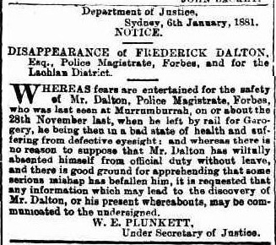
View of Weddin Mountains at the time of the initial gold rush
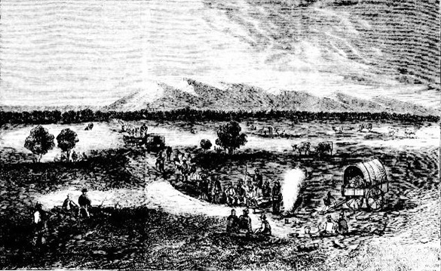

Commissioner Hardy collecting licence fees, by George Lacy, c.1852 National Library of Australia, 3103343
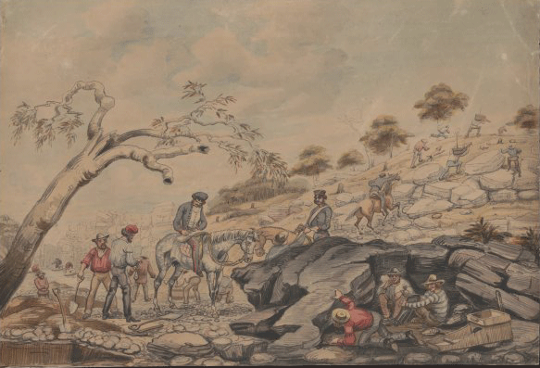
Gold Commissioners Hut Tambaroora Diggings, Henry Scott Montagu, 1853 State Library of NSW, 845961
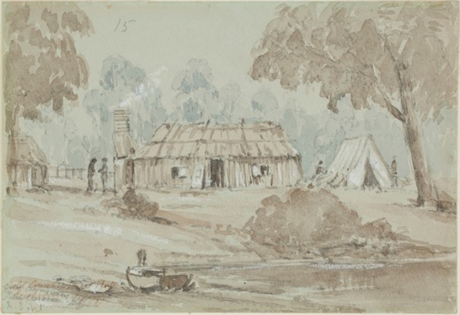

petition from the Chinese residents on the Rocky River to retain Dalton as commssioner. The original is held by the State Archives of NSW.
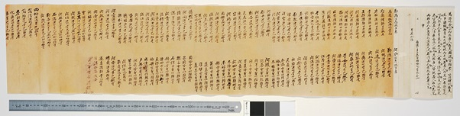
Grenfell diggings. As reported at the time all of the trees were felled for building material and props for mining tunnels. NSW Dept of Mines
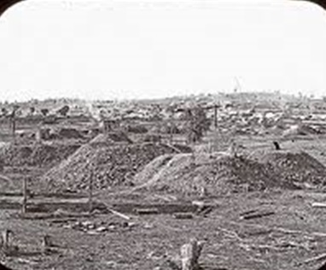
image from Samuel Sidney's book The Three Colonies of Australia: New South Wales Victoria South Australia: Their Pastures Copper Mines and Gold Fields
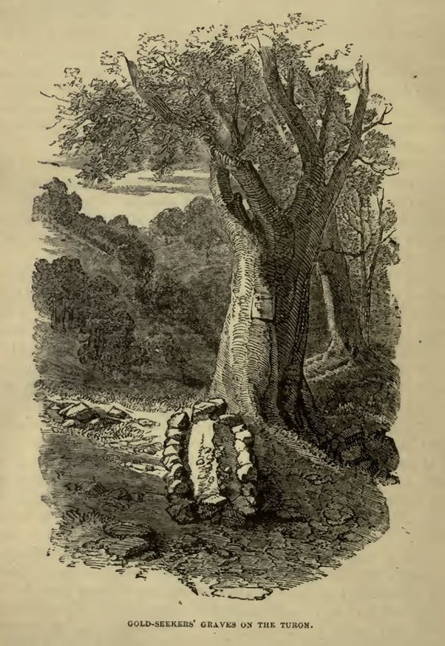
Frederick Dalton's recorded travels in New South Wales. It includes the gold regions he wrote about and the towns where he and Rosa were based in the course of their public service career. The map is reproduced with the kind permission of Dr Peter Crabb and Clive Hilliker, Fenner School of Environment and Society, Australian National University
