John Augustus Hux (1826-1864): a colonial goldfields’ reporter
Peter Crabb, Fenner School of Environment and Society, Australian National University
Introduction
Sydney Morning Herald, July 22, 1861, page 4.
So wrote John Augustus Hux in response to death threats he received as a consequence of his reporting of the anti-Chinese riots at Lambing Flat on June 30, 1861. The statement indicates the character of a man who came to Australia in the early 1850s, and then spent most of the rest of his short life on the mid-nineteenth century colonial goldfields. He was one of a number of reporters who wrote about the goldfields for the main city newspapers. They wrote from their personal experience, providing valuable first-hand accounts of the goldfields. Their personal stories are of as much interest as the ones they wrote. Most have yet to be told.
His Family Heritage
John Hux came from what appears to have been an established London family of craftsmen. The oldest known ancestor, his grandfather, William Hux (1730-1780), was a ‘pewterer’. Pewter, a tin alloy, was long used to make plates, dishes, and drinking vessels. One of the older livery companies in the City of London, the Worshipful Company of Pewterers dates from 1348, its Charter being granted in 1474. The industry reached its peak in the late seventeenth century and then declined, largely as a consequence of the new materials and products of the industrial revolution. By the late eighteenth century, the Company’s numbers were small. This may well explain why at least one of their children turned to another craft; Thomas Hux (1760-1825) became a watchmaker. He married Elizabeth Hudson (1761-1843) in 1782, and they had eleven children, including John, who became a watchmaker.
John Hux (1792-1876) was born in Finsbury, and baptised at St Luke, Old Street, Middlesex, on February 5, 1792. He married Jane Rodwell (1798-1835) on November 17, 1819, in Blandford Forum, Dorset. They had at least six children, including John Augustus. In 1828, he was recorded as being a watch maker in Brunswick Place. Jane died about 1835, aged 37. He subsequently married Marie Martha de Boos (1801-1885) on May 26, 1838: he was described as a ‘Watch Manufacturer’ and a ‘Widower’, and living at 41 Percival Street. Marie Martha, a ‘Spinster’, was a daughter of Abraham and Marthe de Boos, and an aunt of Charles Edward de Boos. By 1843, he was listed as ‘John Hux & Sons Watch Manufacturers’; eight years later, he employed three men. He had moved to 10 Spencer Street, Goswell Road, where he remained for over ten years. The Censuses of 1841 through to 1861 described him as a watchmaker; in 1871, he was listed as a ‘Jeweller’ and living at 10 Milton Street. He died in 1876. At the 1881 Census, Marie was described as a ‘Boarding Housekeeper’ and ‘Widow’, living with Louisa (1840-1920), her daughter by Hux, at ‘the abode of a secretary accountant and his family’. Mary Martha died in October 1885, aged 83.
John Augustus was born on August 7, 1826; he was baptized at St James Clerkenwell, on August 4, 1828, on the same occasion as two of his younger brothers. At the 1841 Census, John Augustus was living with his parents and four siblings in Clerkenwell and described as a watch maker. But he was soon to leave the family business of watch and clock making to his brothers.
Two of John Augustus’s younger siblings also have a small part in this story. They were twins, Mary and Harry Rodwell, born in March 1830, in Hampreston, Dorset, a small village east of Wimborne Minster, where they were baptised on April 13, 1830. Jane and her husband travelled from their home in Clerkenwell for the baptisms; Jane may well have been at her family home in Hampreston for the births. Harry was living with his parents in Clerkenwell at the 1851 Census and working as a watchmaker.
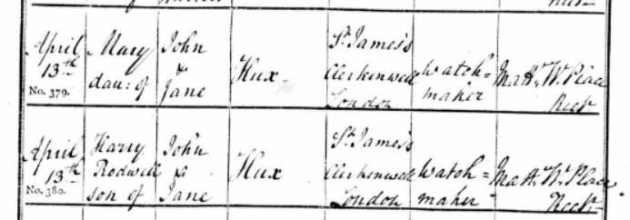
Figure 1. From ‘Baptisms in the Church of England, Parish of Hampreston, Dorset Parish Registers’, Dorset History Centre, Dorchester. Access through www.ancestry.com .
Migration and his Early Years in Australia
John Augustus Hux arrived in Melbourne on January 21, 1853, on the Catherine Mitchell, having sailed from Liverpool. In August the following year, advertisements appeared in The Argus in Melbourne indicating that his sister, Mary, wanted to contact him and their brother Harry:
HUX. – If this should meet the eye of John Augustus or Harry Hux, send a line to your sister Mrs. Connolly, No. 129 Toy Warehouse, Old South Head-road, Sydney.
Just when Mary and Harry arrived in Australia and where they landed is not known, but the lack of a similar advertisement in any Sydney paper suggest that she knew they were somewhere in Victoria. Mary was living in Sydney and married to Matthew Connolly, who had a retail business on South Head Road.
Just over three months after Mary Connolly’s advertisements had appeared, on November 29, 1855, a Mr. Hux arrived in Sydney from Melbourne, having sailed on the City of Sydney. And in February 1858, an unusual notice appeared in the Sydney Morning Herald:
I BEG to acknowledge the RECEIPT of Twenty-one pounds ten shillings and sixpence (£21 12s. 6d.) handed me by Mr. HUX and to return him and all parties subscribing to the same my sincere and grateful thanks for their kind assistance, after the fatal accident by which my husband was killed. EMMA LAWRENCE, February 1st, 1858.
In both cases, we might ask was the ‘Mr. Hux’ John or Harry? And who was Emma Lawrence; what was her connection with ‘Mr Hux’; and what caused him to undertake this charitable task? Emma’s husband may have been the Joseph Lawrence whose accidental death whilst at work was the subject of a Coroner’s inquest, at about the same time as Emma’s notice appeared.
Hux the digger and writer
Victoria
Hux must have quickly become a gold digger, initially in Victoria. It was not long before he was writing letters to newspapers about his goldfields’ experiences, and columns about the goldfields for the same papers (Appendix 1). Some years after the time, he wrote that in the winter of 1854, he “was working on one of the principal [gold] fields in Victoria”, and in late 1858, he stated that he had “had four years’ experience as a gold-digger on the Melbourne side”.
In early 1860, two letters that Hux wrote from Back Creek in Victoria to a friend in Sydney were reproduced in the Sydney Morning Herald. The first was titled ‘The Victoria Gold-fields’ (it did not present a very positive picture); the second, ‘The Gold Fields of New South Wales compared with those of Victoria’. Also from Back Creek, he wrote a letter to The Age entitled ‘The decrease in the yield of gold’. In a letter written later in 1860, he stated that he had “just returned from the Victoria gold-fields”, suggesting that he had had more than one extended period on the Victorian goldfields.
The Fitzroy
In October 1858, two letters on the ‘Fitzroy Diggings’ by John A. Hux, written from the home of his sister at 93 South Head Road, were published in the Sydney Morning Herald. He could not resist another ‘dig’ (Figure 2)! He wrote that on his arrival in Rockhampton, the initial reports were positive; upstream on the Fitzroy River, gold had been found at Canoona, and hardly anyone had returned from there to Rockhampton. However, once at Canoona, he quickly realized that it was a very different story:

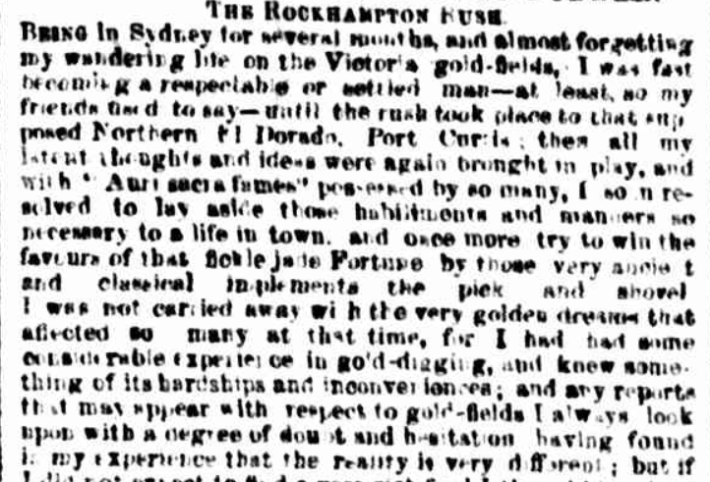
Figure 2. Sydney Morning Herald, June 8, 1860, page 2.
In the morning I commenced a survey of the diggings. The great rush had not yet taken place for we were only the second vessel that had arrived; - but I saw and heard quite sufficient to convince me that Canoona was no place for me.
Along with hundreds of others, Hux and his party found extremely little gold or nothing at all.
In the two letters and a long article on ‘The Rockhampton Rush’, Hux wrote in some detail about the Fitzroy and the failure of the Rush, the dreadful conditions, food shortages, and the impacts on the many men who had made the fruitless journey north (Figure 3). He also wrote of the costs to the shipping companies, who were unable to land their cargoes. Hux’s letters were reprinted, in whole or in part, in a number of other newspapers.

Figure 3. Sydney Morning Herald, October 12, 1858, page 5.
New South Wales
After his trip to the Fitzroy, Hux arrived in Sydney, “if not richer perhaps a wiser man”. He then acknowledged another personal characteristic: “The roving disposition once commenced, it is difficult to say when it will stop”. So, when the “opportunity” arose, he was soon visiting the Maitland and Singleton district in the Hunter Valley. However, he “saw nothing there worthy of notice except the roads”. He spent Christmas Day, 1858, in Sydney; on New Year’s Day, 1859, he was on the Wonga Wonga sailing for Melbourne.
Later in 1860, when again back at his sister’s Sydney residence, Hux wrote three more letters, mostly about the New South Wales goldfields. Two were published in the Herald, the first being about the goldfields in Victoria, New South Wales, and the Fitzroy. The second was a long letter headed ‘The Gold-fields of New South Wales’, and it included comment on the Rev. W.B. Clarke’s 1851-52 report to the Colonial government. The third letter was published in The Sydney Mail and headed ‘Gold Digging at the Snowy River’. Early in 1861, he wrote another letter to the Herald entitled ‘The Chinese Question’, presenting the arguments for and against further Chinese migration.
Reminiscences
In 1860-1861, Hux wrote a number of fictional items, though he was at pains to point out that they were all based on fact. He was identified as the author by the use of his initials, ‘J.A.H.’. A series entitled ‘Reminiscences of a Gold-Digger’, was published in the Sydney Morning Herald in 1860, with a much shorter second series in 1861 (Appendix 2). One was very definitely factual, ‘The Rockhampton Rush’ being some of his experiences on a trip to the Canoona Goldfield (see above). Some were re-published in other newspapers; in the case of The Age, there was no acknowledgement of the source, much to the disgust of ‘M.C.’, who called it “piracy” (Figure 4).
Figure 4. Sydney Morning Herald, August 14, 1860, page 5.
Late in 1860, a serialized story by ‘J.A.H.’ appeared in the Sydney Mail, entitled ‘Emma Westan: a tale of Australia, founded on fact’. In early 1861, two issues of The Sydney Mail contained a column entitled ‘Extracts from my Note-Book’ by ‘J.A.H.’.
A Reporter for the Sydney Morning Herald
His letters, and the knowledge of gold mining he demonstrated, may well have contributed to him being employed by the Sydney Morning Herald as ‘Our Special Commissioner’. It may also have had something to do with the family relationship with Charles de Boos; they may have met in Melbourne, Sydney and/or the Fitzroy Diggings, as they were both in these places at about the same times. Hux’s first destination as the Herald’s ‘Special Commissioner’ was Kiandra.
Kiandra
Kiandra is located at an elevation of some 1400 metres in the Snowy Mountains. The long-ago glaciated country is isolated, exposed, stark, and being in a frost-hollow, almost treeless. Even in summer, it can be very cold (Figure 5). After European settlement, the country was used for summer grazing by sheep and cattle. It was two graziers, David and James Pollock, who discovered gold in payable quantities in November 1859, in Pollocks Gully. “People came from all over Australia and what had once been isolated grazing country suddenly became a boom town. By March 1860
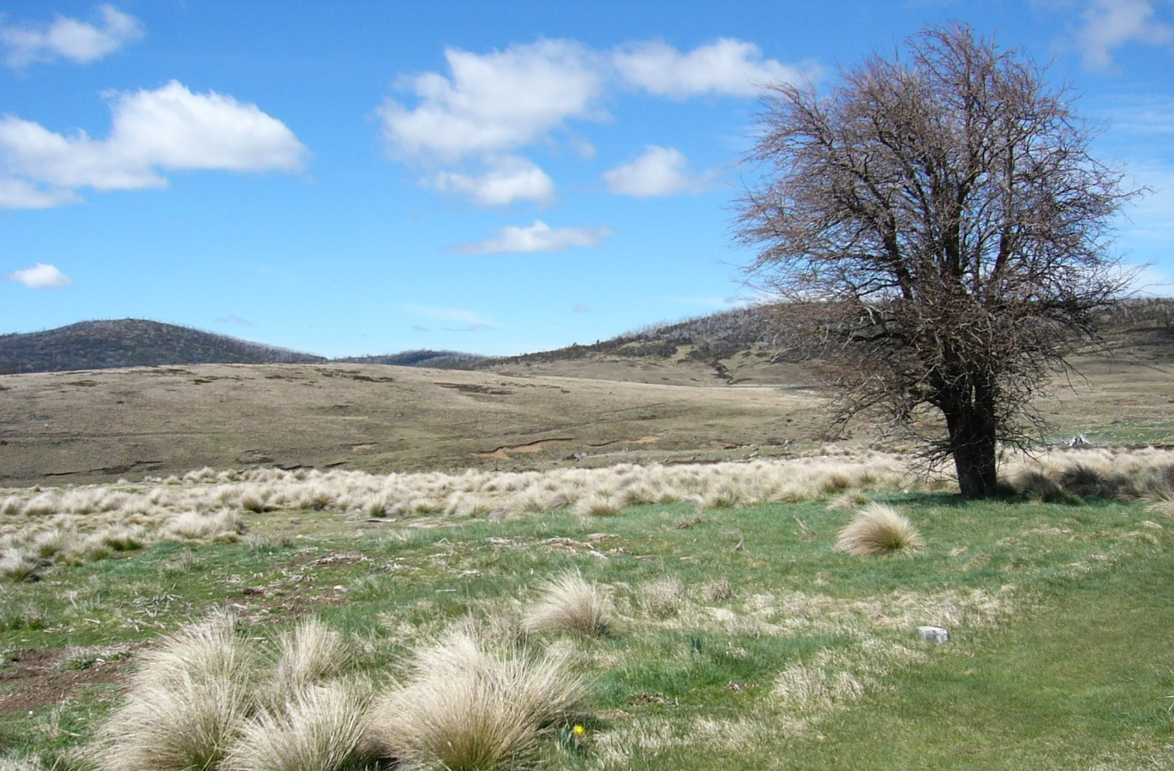
Figure 5. The site of part of the old town of Kiandra. Source: Peter Crabb, October 9, 2014.
there were more than 10,000 people on the goldfields”. The numbers included many Chinese. It was a real ‘rush’. “At its peak, the town comprised a bank, post office, 25 stores, 13 bakers, 16 butchers, 14 hotels, 4 blacksmiths, a courthouse, gaol, school and local newspaper”.
The Kiandra gold rush that began in March-April 1860, had been the subject of a number of reports, editorials, and letters in the Sydney Morning Herald in the first half of the year, with frequent reports by ‘Our Correspondent’, both before and after Hux arrived. Hux, however, provided commentary as well as factual reporting. His reports on the Kiandra gold rush appeared in the Herald from September 28, 1860, to January 14, 1861 (Appendix 2). There were also two separate reports by ‘J.A.H.’. Over the same period that Hux’s reports were published, other articles under the general heading ‘Alpine Sketches’ appeared in the Sydney Morning Herald and The Sydney Mail, that complemented his writings. In addition, two official reports were written about the Kiandra goldfields.
Hux wrote about the difficulties of getting to Kiandra; the township, which by mid-October was “already [beginning] to assume a very respectable appearance”; and the harsh living conditions, especially for those living in tents. He wrote about the mining methods, essentially sluicing the alluvial deposits, and the various locations at which mining was taking place: Rocky Plains, Pollock’s
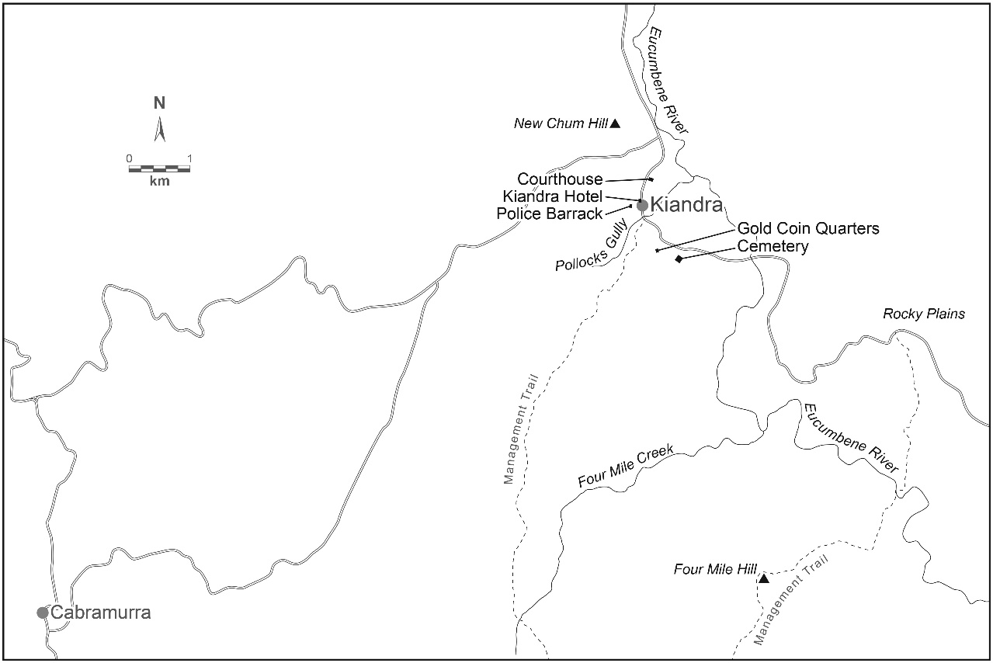
Figure 6. Kiandra and district.
Gully, Nine Mile, Four Mile, Surface Hill, New Chum Hill, Tantangara, the Tumut River (Figure 6). Hux wrote at some length about various management issues, and the problems the Commissioners had as a consequence of them, as well as those they seemed to create for themselves; the fact that the nearest sittings of the District Court were 6 miles away in Cooma; and issues of ‘sly grog’ among the Europeans and opium among the Chinese miners.
The two articles with his initials attached present a somewhat different view of Kiandra. A visit to the cemetery with its unmarked graves was a time for reflection on who they might be, as well as the story of one of those buried. A somewhat tongue-in-cheek account of Kiandra, where he was still trudging through snow, slush and mud at the end of November, gives a picture of many buildings in a very poor state, unable to keep out the rain and snow. He concluded the account of his ramble with the comment, “I think you will agree with a friend of mine, who said that one thing alone was wanted to make Kiandra perfect, and that was an earthquake”.
There was one topic that appeared in almost all of Hux’s reports, the weather. Many endured the cold and heavy snow falls of the 1860 winter; many were ill-prepared and living in canvas tents. It was a harsh environment in which to live and work; even the daffodils planted by some of the original miners found it hard (Figure 7)! Perhaps the hardest aspect of the weather to cope with was its variability from one day to the next, regardless of the season (Figures 8 and 9). Nonetheless, there is a suggestion that some of the Chinese miners undertook some market gardening.
Figure 7. On this exposed site, even the daffodils, descendants of those planted by the miners around 1860, are small. Source: Peter Crabb, October 9, 2014.
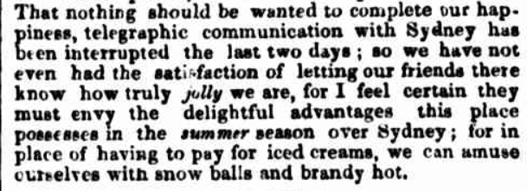
Figure 8. Sydney Morning Herald, November 27, 1860, page 3. Lightning strikes on the telegraph wires often caused cuts to the telegraph services.
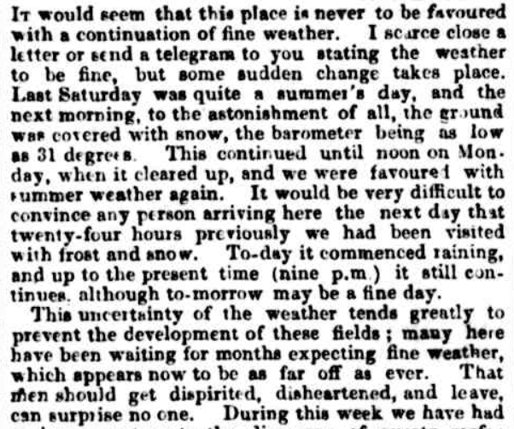
Figure 9. Sydney Morning Herald, November 26, 1860, page 5.
While it lasted, Kiandra was a very productive goldfield; many miners did very well, including the Chinese. For example, in one ten-day period, a group of miners had found a 12 lbs nugget plus 70 ozs of other gold. The largely alluvial workings produced over 67,600 ozs in 1860 and 16,500 ozs in 1861. Its decline seems to have been rapid, as significant quantities of gold were being sent to Sydney through to late November, and a 24-25 lbs nugget was found in early December. By November, however, Hux was writing of people leaving for Crackenback (initially called ‘Crack-em-back’), a location of short-lived activities, and more particularly, many were leaving for Lambing Flat. By mid-December, Hux wrote, “This place is getting quite deserted”. It had been one of the biggest and shortest gold rushes in Australia. Nonetheless, there were plenty of celebrations for Christmas and New Year, the latter including horse racing (Figure 10).

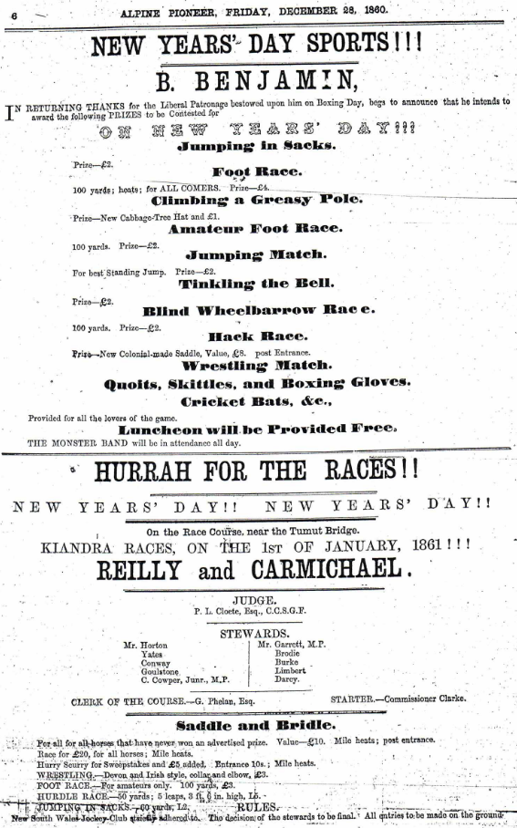

Figure 10. ‘New Year’s Day Sports and Races’, Kiandra, 1861. Alpine Pioneer and Kiandra Advertiser, December 28, 1860, page 6.

Hux did not experience the massive snowstorm in late July 1860, which no doubt provided the impetus for an activity that gave Kiandra a world-first. In that winter, skiing or snowshoeing was introduced by three Norwegian miners, Elias Gottraas, Soren Tor, and Carl Bjerknes. Skis, or snowshoes, were essential to move about. Soon, however, they provided a source of pleasure and, in 1861, Kiandra became the first place in the world to have an alpine ski club and to have ski races.
On January 8, 1861, Hux joined those leaving Kiandra for Lambing Flat. Before doing so, he expressed his appreciation to those he had worked with, both Government officials and miners, and was the recipient of an unusual presentation (Figure 11).
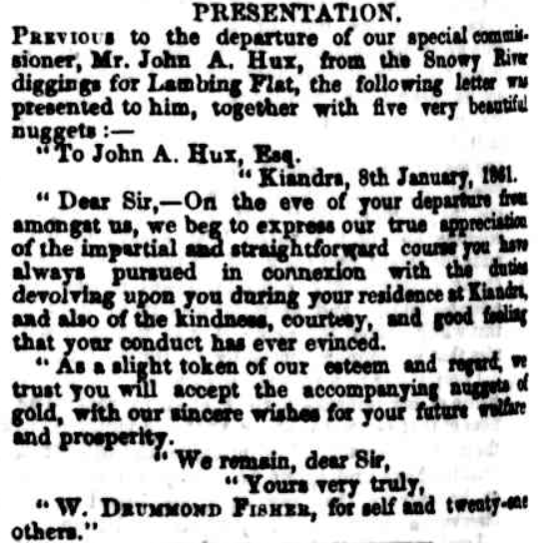
Figure 11. Sydney Morning Herald, January 22, 1861, page 4.
Lambing Flat
By the time Hux left, the Kiandra rush was over. By early March, there were “not more than 200 diggers left”. Hux’s destination was the same as most of the diggers leaving Kiandra, namely Lambing Flat (now known as Young) (Figure 12).
Gold was first discovered at Lambing Flat in March 1860. Over the next few months, numerous other finds were made in the district, extending up to some twenty miles from the centre of the field at Lambing Flat. Large numbers of diggers, European and Chinese, were attracted to the district; by late November, the population was at least some 3,000. From very early in the goldfield’s history, it seems to have been a lawless place, with anti-social behaviour and robberies (not least of horses) common. In November 1860, the first anti-Chinese actions occurred, with some 500 driven off their diggings: “John Chinaman was obliged to make himself scarce, and as soon as he was driven off the ground, all the tents were demolished in an instant. We believe that no violence to the person was committed in getting rid of the pests”.
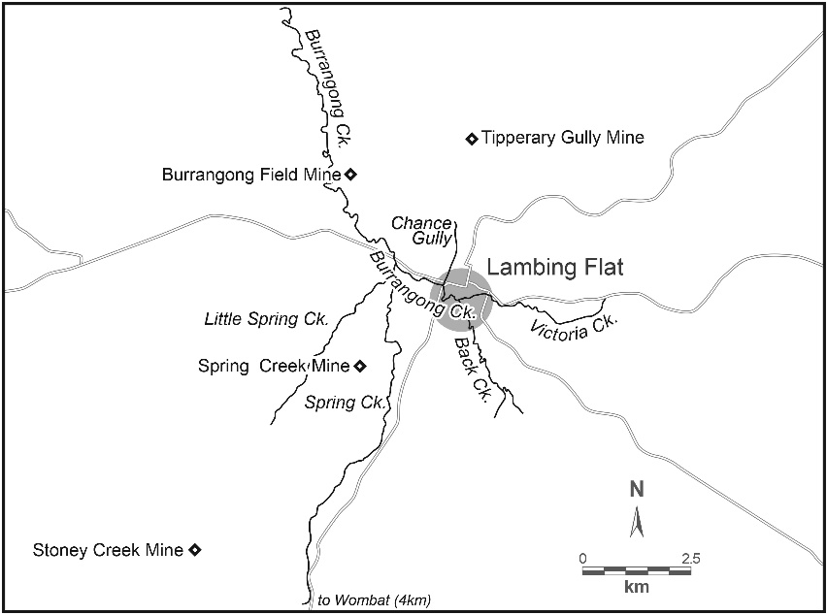
Figure 12. Lambing Flat.
Anti-Chinese sentiment and actions continued into 1861, and there were a number of large public meetings. It was in this situation that another ‘Special Commissioner’ began reporting for the Sydney Morning Herald. Who this was has yet to be determined. With one exception, the reports were short, of a factual nature, with little comment. Over the period from February to April, 1861, they provide an eye-witness account of the events that took place, in contrast to much misreporting, of the troubles between the European and Chinese miners, even from Government officials. In late January, 1861, some 1,500 Chinese were driven off the land they were working, in defiance of the Commissioner and the police; there were so few police, that they were unable to do anything. A petition against the “invasion of the Chinese” and wanting their removal attracted
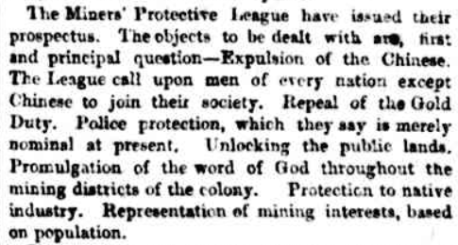
Figure 13. Sydney Morning Herald, March 6, 1861, page 4.
3,394 signatures. The Miners’ Protective League made its position very clear (Figure 13); so too did the Sydney Morning Herald, in demanding the fair and lawful treatment of all miners, regardless of race, European and Chinese. Even before the worst riots, in the words of the Editor, the Rev. John West, a Congregational minister, the persecution of the Chinese was unreservedly condemned, as was the inaction of the Government:
The long silence of the Government respecting the proceedings at Lambing Flat will be there interpreted one way – assent. The spirit which shrinks from any unpopular duty is one of the characteristic results of democratic ascendency. It is in vain to appeal to the principles of justice – to the rights of humanity – the claims of law – the sanctity of public faith. These are powerless before that cowardly spirit which cringes to the lowest of the people. Could any civilised Government be found that wold not vindicate itself by declaring at the outset, and in decided terms, its determination to protect to the utmost of its means defenceless strangers, who have on their side right, humanity, and law.
The history of the Lambing Flat is an illustration of the brutal temper which prevails among the migratory bands of diggers. We gladly distinguish them from a very respectable class, who have given to gold mining the aspect of a settled industry, and whose conduct has been honest and fair. The Lambing Flat was discovered as a gold-field by the Chinese themselves. They were entitled by law to settle there; they obtained and paid for the miner’s right; they were put in possession by the Government. No one pretends they have forfeited that protection which any man who lives under the English flag has the right to expect. The intruders, if any deserve the name where all have a defined and equal right, are the white men, for we will not disgrace our country by calling them Englishmen. The Chinese have been ejected, and robbed are their legal rights – driven off the ground, and exposed to want and starvation. And all this has been done in an “orderly manner” forsooth! We are told there is no violence – no one has been attacked – they have only been driven off!
Petitions for compensation by the Chinese for losses from the riots that occurred in January and February 1861, provided them with little joy. A Government Inquiry by William Campbell of Burrowa, into the claims could well be described as a whitewash: “the destruction of property on the occasion of the removal of the Chinese from Lambing Flat on 27th January and 17th February 1861, was very trifling, and that the claims hereinbefore referred to are altogether fraudulent”. Further, Henley’s support of one claim was dismissed, Campbell stating that Henley “must have been labouring under an excited imagination”.
Hux took much longer to reach Lambing Flat than did most of the diggers who had left Kiandra. In his second report from Lambing Flat, he wrote:
In leaving Kiandra some two months since I little thought that circumstances would have prevented my arrival here for nearly two months. … I have been here so short a time.
What the “circumstances” were, he did not say.
For almost a year, from April 1861, to March 1862, Hux wrote over seventy-five reports from Lambing Flat as the Herald’s ‘Special Commissioner’ (Appendix 4). His first report was a detailed account of the ‘Great Monster Meeting on the Chinese Question’. It was the first of many meetings, acts of violence, and riots against the Chinese that Hux reported, some large, some small, such as, “I noticed in town yesterday more Chinese than I had seen for a long time. I also noticed one crowd of intelligent men amusing themselves by throwing rubbish at them”.
During a visit to Lambing Flat, Premier Charles Cowper made many statements supportive of the miners and the Chinese, including in his address to a large meeting, but when he returned to Sydney, his statements in the Legislative Assembly were totally different. Not surprisingly, ‘Slippery Charlie’ was attacked by locals and Hux for his “misrepresentation”. There was more serious trouble on the last day of June 1861, when thousands were involved; among other things, the Court House and Commissioners’ camp were burned down. These riots were particularly bad for the Chinese, and no doubt they would have been worse but for the interventions of James Henley (Figure 14). The petition to the government signed by fifty-one Chinese residents seeking an inquiry into the riot and a request for compensation for their losses almost certainly had the assistance of Henley (Figure 15).
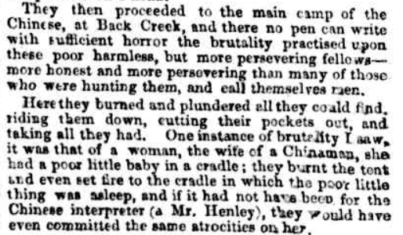
Figure 14. Sydney Morning Herald, July 13, 1861, page 5.
Hux was forced to move to Yass for a short time because of death threats from people who, not for the first time, did not like his reporting: but, as noted in the epigraph, he was fearless in his reporting and in its accuracy. With far too few police and government officials to maintain law and
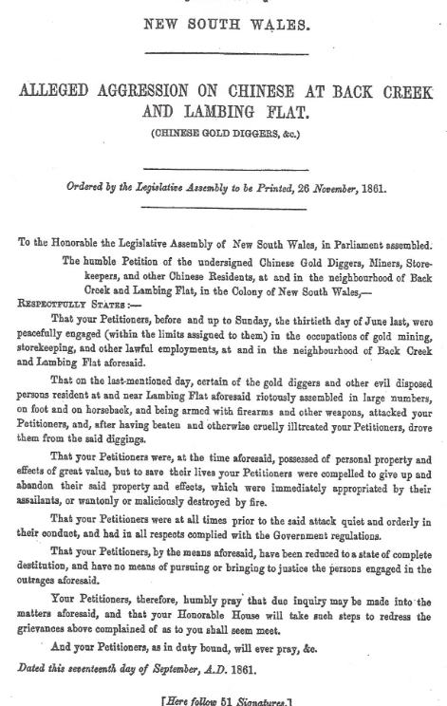

Figure 15. Petition to the Colonial Government regarding ‘Alleged Aggression on the Chinese at Back Creek and Lambing Flat’, on June 30, 1861. NSW Votes and Proceedings of the Legislative Assembly, 1861-1862, Volume 2, page 9. Government Printer, Sydney. On pages 1-7, there were four other petitions regarding ‘Alleged Aggression upon Chinese at Lambing Flat’ from individual Chinese residents of Lambing Flat.
order, many disturbances could not be dealt with. The same observation applied to problems of management, though these were often the fault of the Government and its regulations, rather than the local officials (Figure 16).
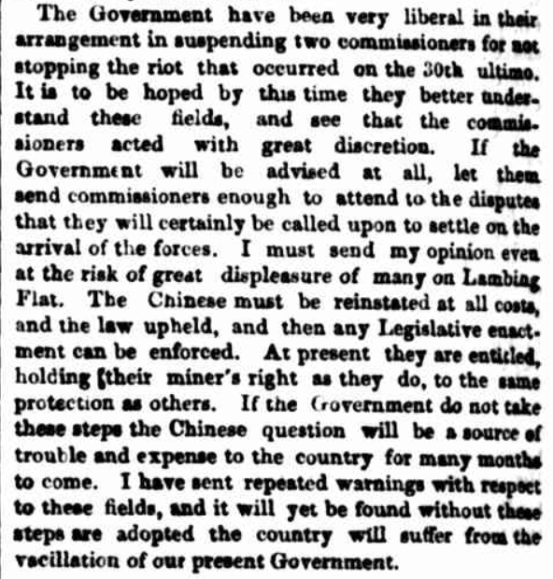
Figure 16. Sydney Morning Herald, July 20, 1861, page 4.
The Sunday, June 30, 1861, riots were the last major disturbances in Lambing Flat. True, there were on-going problems, but over the following months, the situation gradually improved, in no small measure due to some very good officials who worked in the district, such as Captain J.L. Wilkie, who

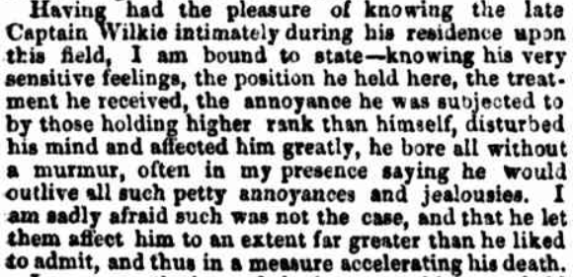
Figure 17. Sydney Morning Herald, February 10, 1862, page 5.
was highly regarded by everyone. When he died suddenly, the town closed for the funeral, in which over 3,000 diggers marched, and large numbers lined the streets (Figure 17). The improving situation in Lambing Flat may also have been helped by some miners moving to the newly opened Lachlan diggings (some 90 miles away) and to New Zealand, along with a greater number of miners from Victoria, “who, as a rule, look upon Commissioners’ decisions as final”. And, it must be remembered, not all of the residents of Lambing Flat shared the views of what may have been the majority.
In amongst the accounts of continuing troubles, there was information on the gold mining areas and gold production, but European-Chinese relations and the persecution of the Chinese dominate Hux’s reports from Lambing Flat. He deplored the lawless treatment of the Chinese, and in this he was fully supported by the editorial position of the Herald. It was not that the anti-Chinese activities were unique to the Lambing Flat goldfields, but that, culminating in the June 30 riots, they were perhaps the worst experienced in Australia.
Along with those of the other ‘Special Commissioner’, the reports of Hux provide a valuable eye-witness account of one of the darkest chapters in Australia’s history, a chapter that has had a lasting impact. But their views were not shared by other eye-witnesses, namely the Editor and others who worked for The Miner and General Advertiser, which was published in Lambing Flat from February 2, 1861, to November 13, 1861, and then in Forbes from December 4, 1861. In his book, Country Conscience: a history of the New South Wales provincial press, 1841-1995, Kilpatrick provides a summary of the events, headed “The Black Mark of Disgrace: the press and the Lambing Flat riots”. Yet “the press” is almost entirely limited to The Miner. Apart from denials by The Miner of statements in the Herald, there were no references to any of Hux’s reports. The summary by Kirkpatrick and the reports in The Miner, present a different ‘eye-witness’ picture to that of Hux. The Miner and its Editor were very supportive of the European miners and the Miners’ Protective League. They were anti-Chinese and even more strongly opposed to continuing Chinese migration. As well, they were strongly critical of the Colonial Government, the Fairfax company, and the Herald’s ‘Special Commissioner’. The Herald was accused of inaccurate and misleading reporting. The Miner’s reports of the “monster meetings” that took place are certainly different to those published in the Herald. For a fuller story of Lambing Flat in 1860-1861, the accounts in both papers should perhaps be read.
The Lachlan Diggings
From November 1861, to May 1862, before his work in Lambing Flat had finished, Hux was also reporting on the new gold mining locations in the Lachlan Valley, usually referred to as the ‘Lachlan Diggings’ or ‘The Lachlan’. He wrote twenty-one articles about them (Appendix 4).
The Lachlan Diggings were centred on Forbes, some 80 miles from Lambing Flat. The distance and journey by way of Cowra did not give rise to any comment from him. On his first visit, he was able to say that “The population is quiet and orderly”, a marked contrast to Lambing Flat. However, with a population of some 10,000, he was nonetheless concerned at the limited number of police, as he was sure that management problems were going to cause “great trouble”, especially the frontage system of claims, before it was soon abandoned. However, difficulties continued with the new Gold Fields Act.
But in the absence of the kind of problems that had affected Lambing Flat (there are no references to Chinese miners in his reports), Hux was able to concentrate on the gold mining and production. By late 1861 – early 1862, there was no doubt that the Lachlan was “an established and permanent gold-field”, but as to just how productive was still open to question. Hux also reported that there were robberies, and the highway robbers Gardner and Ben Hall were active in the area. A brief visit from Premier Charles Cowper left Hux and most local people wondering what he had come for. Still, there was much mining activity, some large gold finds had been made, and the town of Forbes was booming. And being the reporter he was, it is not surprising that “Mr. Hux of the Herald” received a very complimentary mention in a letter by ‘Cosmopolite’ to The Empire on the Lachlan Diggings (Figure 18).
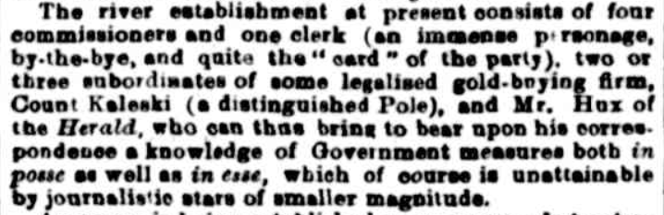
Figure 18. The Empire, December 4, 1861, page 8.
A resident of Lambing Flat
Hux’s reporting for the Sydney Morning Herald came to an end in May-June 1862. A column in the Herald in late June referred to “Mr. John A. Hux, for many months our Special Commissioner on the Gold Fields, a gentleman who has been residing on the Lachlan or Lambing Flat Gold Fields as Correspondent for this journal ever since the latter was opened”. After this, he wrote two ‘Letters to the Editor’ of the Sydney Morning Herald, and though on specific topics, they also provide some details of his work as a reporter (Appendix 5). Both were written from Lambing Flat, indicating that he had remained in the town.
In late 1862, he had a change of career, taking over ‘The Albion Commercial and Family Hotel’ in Lambing Flat. Over thirty advertisements for his business appeared in the Sydney Morning Herald and the Sydney Mail between October 1862 and May 1863 (Figure 19). An advertisement for the 1863 ‘Burrangong Annual Races’ included ‘Mr. J.A. Hux’ in the list of stewards. Just how long he stayed there is not known, but a letter by Hux from Lambing Flat headed ‘Sir Frederick Pottinger’ appeared in the Sydney Morning Herald in July 1863.
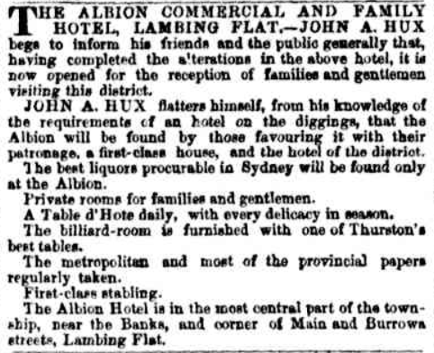
Figure 19. Sydney Morning Herald, October 11, 1862, page 3.
A short but active life
Prior to settling in Lambing Flat, Hux, like so many of his time and especially those associated with gold mining, was almost constantly on the move, travelling widely in eastern Australia, from Melbourne in the south to the Fitzroy River in the north. Yet even his ‘settled’ time in Lambing Flat was not long, as at some time in the latter part of 1863, he moved to Surry Hills in Sydney. What he did on moving to Sydney is not known, but it is unlikely to have been a move he would have wanted. As it happened, it was his last move. After a “long and severe illness” that lasted about twelve months, he died of heart disease on April 21, 1864, aged 38, at the home of his sister, Mrs. Mary Connolly, on South Head Road (Figure 21). He was buried on April 23 in the Randwick Cemetery. On his death certificate, his occupation was listed as ‘Publican’.
Conclusion
This account of the life and work of John Augustus Hux came about as a consequence of research for a biography of Charles Edward de Boos, triggered by the family connections between de Boos and Hux. Until the research was undertaken, the contribution of John Augustus Hux to the writings on the Australian goldfields of the mid-nineteenth century had been unknown.
Despite their wealth of information, very little use has been made of Hux’s writings as a primary source of historical material. This is true even for local studies of Kiandra and Young (Lambing Flat).
Like Charles de Boos, Frederick Dalton and other reporters of his time, he had travelled widely within Australia. Whilst not as large a contributor as de Boos or even Dalton, his writings are of equal value. Like them, he was a keen observer and an accurate and fearless reporter. From Kiandra, he provided first-hand accounts of living and mining in such an isolated location, with its ever-present hazardous weather. His reports from Lambing Flat (along with those of the unknown ‘Special Commissioner’ who preceded him) are of particular value as a first-hand record of the disturbances and anti-Chinese riots that made such a mark on racial relations in Colonial Australia and the country’s subsequent history.
Acknowledgements
Appreciation is extended to Dr Alexis Antonia, Centre for Literary and Linguistic Computing, University of Newcastle, for textual analysis in helping to confirm the attribution of some of Hux’s articles, and for comments on an earlier version of this article. Clive Hilliker is once again thanked for his cartography.

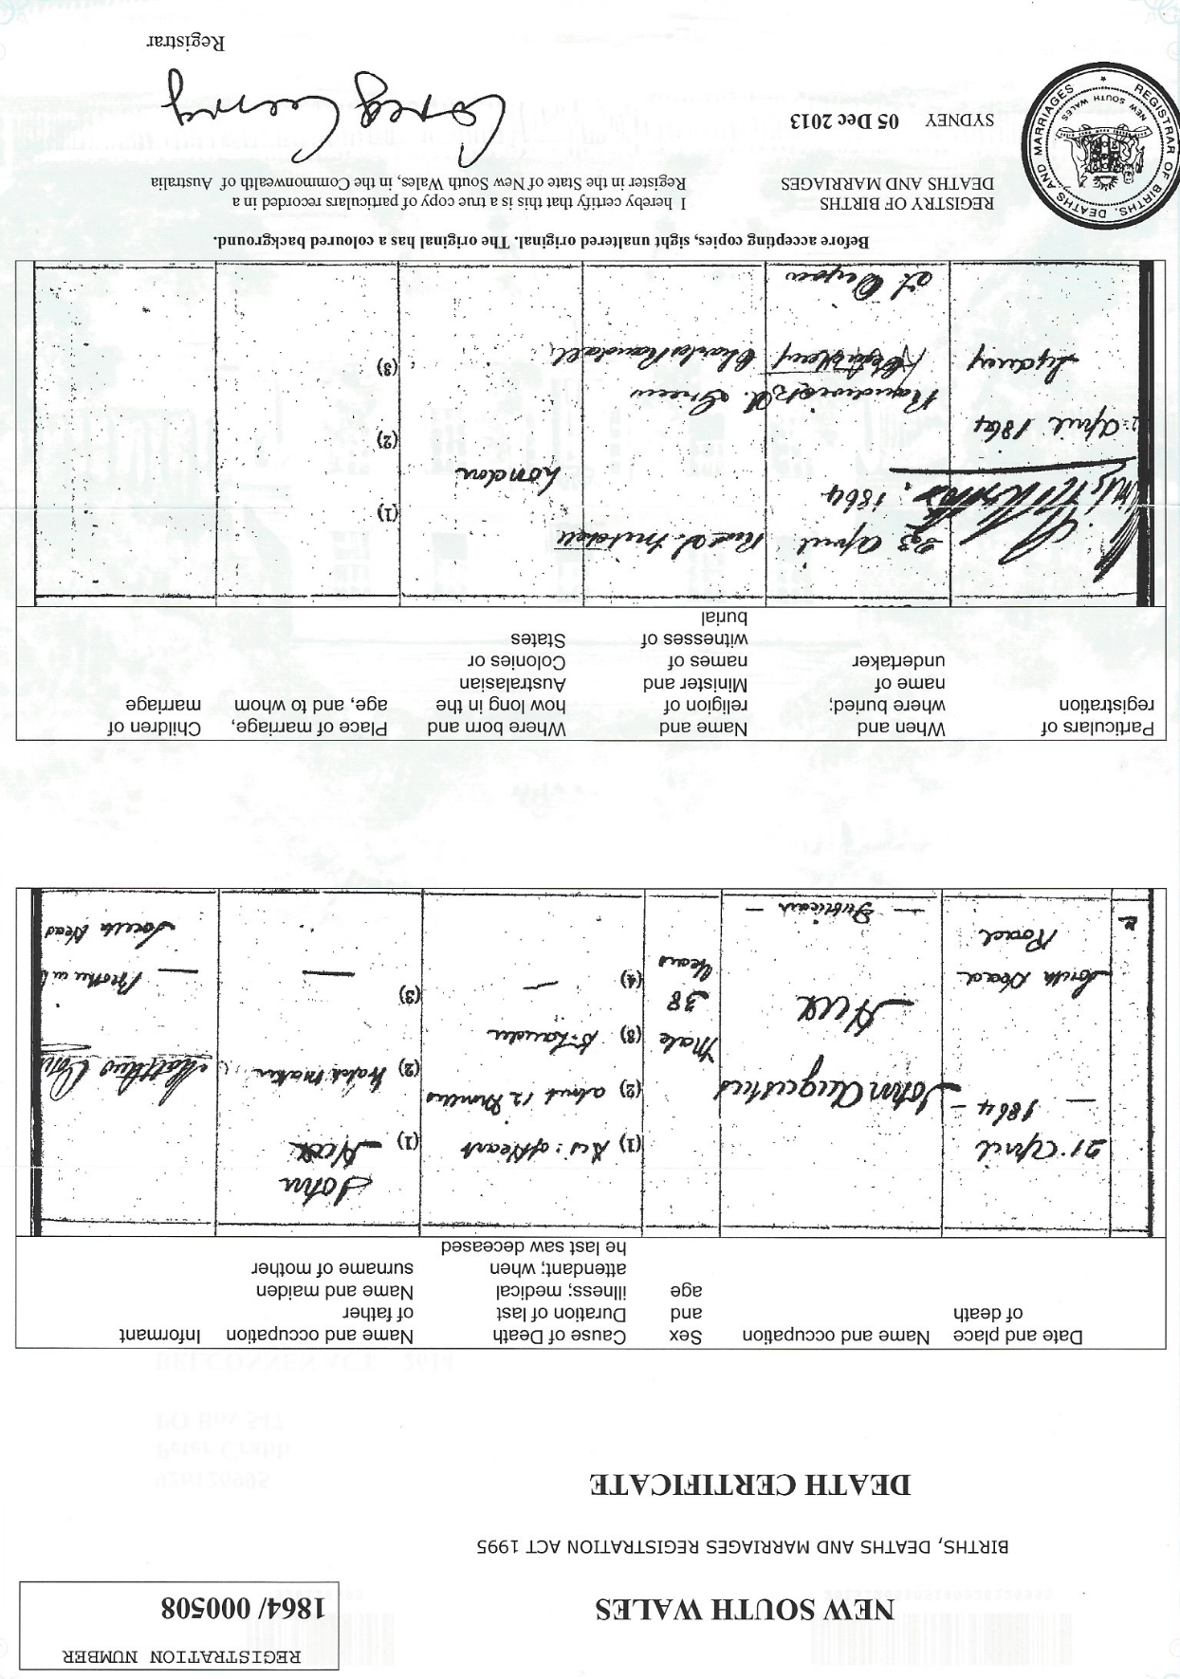
Figure 21. Copy of John Hux’s Death Certificate. NSW Registry of Births Deaths and Marriages, Sydney.

The Writings of John A. Hux, 1858 to 1863
Appendix 1. Miscellaneous Writings, 1858-1861.

Newspaper | Date | Page | Title and other details
Sydney Morning Herald | October 12, 1858 | 5 | “The Fitzroy Gold-fields”. Letter to the Editor.
Sydney Morning Herald | October 13, 1858 | 5 | “The Fitzroy Diggings”. Letter to the Editor.
Sydney Morning Herald | February 25, 1860 | 9 | “The Victoria Gold-fields”. Letter to the Editor.
Sydney Morning Herald | March 13, 1860 | 13 | “The gold-fields of New South Wales compared with those of Victoria”. Letter to the Editor.
The Age | April 26, 1860 | 4 | “The decrease in the yield of gold”. Letter to the Editor.
Sydney Morning Herald | June 8, 1860 | 2 | “Reminiscences of a Gold-Digger. The Rockhampton Rush”
Sydney Morning Herald | August 27, 1860 | 3 | ‘Snowy River Diggings’. Letter to the Editor.
Sydney Mail | September 1, 1860 | 3 | “Gold digging at the Snowy River”. Letter to the Editor.
Sydney Morning Herald | September 10, 1860 | 3 | “The gold-fields of New South Wales”. Letter to the Editor.
Sydney Mail | October 27, 1860 | 3 | “Emma Westan, a Tale of Australia, founded on fact”, Chapters One, Two and Three.
Sydney Mail | November 3, 1860 | 3 | “Emma Westan, a Tale of Australia, founded on fact”, Chapter Four.
Sydney Morning Herald | November 8, 1860 | 2 | “Graves at Kiandra”. (1)
Sydney Mail | November 10, 1860 | 2 | “Emma Westan, a Tale of Australia, founded on fact”, Chapters Five, Six, and Seven.
Sydney Morning Herald | December 7, 1860 | 2 | “A summer-day’s ramble through Kiandra”. (2)
Sydney Morning Herald | March 1, 1861 | 8 | “The Chinese Question”. Letter to the Editor.
Sydney Mail | March 9, 1861 | 2 | “Extracts from my Note Book, Nos. I and II”.
Sydney Mail | March 16, 1861 | 2 | “Extracts from my Note Book, No. III, IV, and V”. (3)

- Re-published in The Sydney Mail, November 17, 1860, page 6; Launceston Examiner, November 20, 1860, page 2; Twofold Bay Telegraph, November 27, 1860, page 3; Cornwall Chronicle (Launceston), December 15, 1860, page 2.
- Re-published in The Sydney Mail, December 8, 1860, page 2.
- All extracts re-published in the Sydney Morning Herald, March 18,1861, page 2.

Appendix 2. ‘Reminiscences of a Gold-Digger’ by ‘J.A.H.’, Sydney Morning Herald, 1860-1861.
Date | Page | Sub-headings | Published in other papers
April 20 | 2
May 11 | 2 |  | Mount Alexander Mail, May 25, page 7
May 30 | 2
June 1 | 2 |  | The Age, June 12, page 7
June 5 | 5
June 13 | 10
July 3 | 5
July 7 | 4
August 29 | 5 |  | Sydney Mail, September 1, page 2; Examiner (Kiama), September 8, 1860, page 4; Clarence & Richmond Examiner, September 11, 1860, page 4; Mount Alexander Mail, September 14, 1860, page 7.
February 15 | 2 | Part I | Sydney Mail, February 16, page 2; Mount Alexander Mail, March 15, page 7.
March 4 | 2 | Part II | Sydney Mail, March 2, page 2; Mount Alexander Mail, March 22, page 7.

Appendix 3. Hux on Kiandra, Sydney Morning Herald, 1860-1861.
Date | Page | Title | Published in other papers
September 28 | 5 | En Route to Kiandra
October 11 | 10 (2 items) | Latest from Kiandra | “News from Kiandra”, Sydney Mail, October 13, 1860, page 5.
October 13 | 7 | Kiandra
October 17 | 5 | Kiandra | “Kiandra”, Sydney Mail, October 20, 1860, page 8.
October 20 | 4 | Kiandra
October 22 | 4 (2 items) | Kiandra | “Gold news from Kiandra’, Sydney Mail, October 27, 1860, page 6.
October 23 | 4 | Kiandra
October 27 | 8 | Kiandra | “Latest from Kiandra’, Sydney Mail, October 27, 1860, page 4.
November 2 | 8 | Kiandra | By “Our Special Correspondent’. “Latest from Kiandra”, Sydney Mail, November 3, 1860, page 5.
November 7 | 8 | Kiandra | “Gold News. Kiandra”, Sydney Mail, November 10, 1860, page 3.
 |  |  | “Latest from Kiandra”, Sydney Mail, November 10, 1860, page 5.
November 12 | 4 | Kiandra
November 14 | 5 | Kiandra
November 17 | 7 | Kiandra | “Latest from Kiandra”, Sydney Mail, November 17, 1860, page 4.
November 26 | 5 | Kiandra | “Gold News. Kiandra”, Sydney Mail, December 1, 1860, page 3.
November 27 | 3 | Kiandra
November 29 | 3 | Kiandra | “Latest from Kiandra”, Sydney Mail, December 1, 1860, page 4.
December 1 | 6 | Kiandra
December 5 | 4 | Kiandra
December 7 | 5 | Kiandra | “Latest from Kiandra”, Sydney Mail, December 8, 1860, page 4.
December 8 | 5 | Kiandra
December 12 | 5 | Kiandra | “Gold News. Kiandra”, Sydney Mail, December 15, 1860, page 2.
December 14 | 4 | Kiandra
December 15 | 6 | Kiandra
December 18 | 9 | Kiandra | “Kiandra”, Sydney Mail, December 22, 1860, page 4.
December 22 | 5 | Kiandra
December 24 | 4 | Kiandra
December 31 | 5 | Kiandra | “Gold News. Kiandra”, Sydney Mail, January 5, 1861, page 2.
January 2 | 5 | Kiandra
January 8 | 5 | Kiandra | “Gold News. Kiandra”, Sydney Mail, January 12, 1861, page 6.
January 14 | 3 | Kiandra | “I purpose leaving this place to-morrow [January 8] for Lambing Flat”.
January 19 | 5 | Kiandra | Written on January 13. Sydney Mail, January 26, 1861, page 8.

Appendix 4. Hux on Lambing Flat, Sydney Morning Herald, 1861-1862.
April 2 | 6 | Lambing Flat: Great Monster Meeting on the Chinese Question
April 9 | 3 | Lambing Flat
April 12 | 8 | Lambing Flat
April 15 | 2 | Lambing Flat
April 19 | 8 | Lambing Flat
April 26 | 5 | Lambing Flat
May 2 | 8 | Lambing Flat
May 7 | 3 and 4 | Lambing Flat
May 11 | 7 | Lambing Flat
May 14 | 4 | Lambing Flat
May 17 | 4 | Lambing Flat
May 21 | 13 | Lambing Flat
May 22 | 4 | Lambing Flat
May 24 | 4 | Lambing Flat
May 25 | 5 | Lambing Flat
May 28 | 4 | Lambing Flat
May 31 | 5 | Lambing Flat
June 1 | 4 | Lambing Flat
June 5 | 3 | Lambing Flat
June 8 | 4 | Lambing Flat
June 17 | 5 | Lambing Flat
June 18 | 4 | Lambing Flat
June 21 | 3 | Lambing Flat
June 25 | 4 | Lambing Flat
June 28 | 8 | Lambing Flat
July 2 | 4 | Lambing Flat
July 4 | 4 | Lambing Flat
July 9 | 5 and 4 | Lambing Flat. Includes a copy of a long letter from ‘James McCulloch Henley, Anglo-Chinese Linguist’, on behalf of the Chinese, to the Governor, Sir John Young. Together, the report and letter provide a detailed account of the dreadful treatment of the Chinese miners.
July 15 | 4 | Lambing Flat
July 17 | 4 | “Riot at Lambing Flat. Fatal Collision between Rioters and Police” (from Burrangong)
July 18 | 4 | Lambing Flat. Yass
July 20 | 4 | Yass
July 22 | 4 | Yass
July 30 | 4 | Yass
August 1 | 4 | Yass: Roberts’ Station.
August 5 | 4 | Lambing Flat
August 6 | 4 (two reports) | Lambing Flat
August 8 | 4 | Lambing Flat
August 9 | 8 | Lambing Flat
August 13 | 4 | Lambing Flat
August 14 | 5 | Lambing Flat
August 17 | 4 | Lambing Flat
August 19 | 4 | Lambing Flat
August 20 | 4 and 5 | Lambing Flat
August 21 | 6-7 | Riot at Lambing Flat. Extended account of court case.
August 23 | 5 | Lambing Flat
August 24 | 4 | Lambing Flat
August 30 | 4 and 5 | Lambing Flat
September 2 | 8 and 4 | Lambing Flat
September 4 | 5 | Lambing Flat
September 9 | 5 | Burrangong: Police Court
September 16 | 2 | Lambing Flat
September 24 | 5 | Lambing Flat
September 30 | 5 | Lambing Flat
October 3 | 8 | Lambing Flat
October 12 | 7 | Lambing Flat
October 16 | 3 | Lambing Flat
October 19 | 5 | Lambing Flat
October 22 | 5 | Lambing Flat
October 24 | 2 | Lambing Flat: Police Court
November 16 | 4 and 6 | Lambing Flat
February 10 | 5 | “The Death of Captain J.L. Wilkie, of H.M. 12th Regiment”.
February 10 | 5 | Lambing Flat: includes material on Lachlan Diggings
February 12 | 3 | Lambing Flat
February 18 | 3 | Lambing Flat
March 1 | 5 | Lambing Flat
March 4 | 2 | Lambing Flat
March 6 | 5 | Lambing Flat
March 10 | 5 | Lambing Flat: Police Court
March 15 | 4-5 | “Lambing Flat. Highway Robbery by Gardiner and his Mates”; Police Court
March 21 | 3 | Lambing Flat

Appendix 4. Hux on the Lachlan Diggings, Sydney Morning Herald, 1861-1862.
Date | Page | Title
November 11 | 2 | Lachlan Diggings
November 16 | 6 | Included in Lambing Flat
November 26 | 4 | Lachlan Diggings
November 28 | 5 | The Lachlan
November 29 | 4 | Lachlan Diggings
December 3 | 4 | Lachlan Diggings
December 4 | 5 | The Lachlan
December 6 | 8 | Lachlan Diggings
December 13 | 8 | Lachlan
December 14 | 6 | Lachlan
December 27 | 4 | Lachlan
January 7 | 4 | The Lachlan
January 16 | 2 | The Lachlan
January 23 | 5 | Lachlan
February 10 | 5 | Lambing Flat: includes comments on the Lachlan Diggings
April 14 | 5 | The Lachlan
April 24 | 5 | The Lachlan
May 1 | 2 | The Lachlan
May 8 | 8 | Lachlan
May 16 | 5 | The Lachlan

Appendix 5. Hux’s last writings: ‘Letters to the Editor’ of the Sydney Morning Herald, 1862-1863.
Date | Page | Title
June 18, 1862 | 2 | “The Escort Robbery”
October 3, 1862 | 8 | “Bridges and Post-Office, Lambing Flat”
July 25, 1863 | 7 | “Sir Frederick Pottinger”

Sydney Morning Herald, July 22, 1861, page 4.
www.pewterers.org.uk
The marriage record stated that John Hux was of the Parish of Blandford Forum and Jane Rodwell was of the Parish of Hampreston.
There was also a more direct family relationship with Charles de Boos. See Peter Crabb (2015): “’His life history may be told in a few words’: Charles Edward Augustus de Boos, 1819-1900”. pp. 109-120 in A New Tapestry: Australian Huguenot families, edited by Robert Nash. The Huguenot Society of Australia, Sydney.
Post Office Commercial Directory, London, 1848, page 878, and 1851, page 812.
The previous year, they had another daughter, Florence (1839-1843), but she only lived for four years.
http://trees.ancestrylibrary.com/tree/25190412/person/1659018516 .
Some sources give his name as John Augustus Rodwell Hux.
Public Records Office Victoria, Unassisted Passenger Arrivals, www.prov.vic.gov.au ; The Argus, January 22, 1853, page 4.
The Argus, August 10, 1854, page 1; August 11, 1854, page 2.
Sydney Morning Herald, July 9, 1864, page 8; he also ran a “Circulation Library”, Empire, August 12, 1852, page 2. What became of Harry after this inquiry is not known, not is anything further known about Mary following the death of John Augustus in 1864 (see below).
The Empire, November 30, 1855, page 4.
Sydney Morning Herald, February 2, 1858, page 1.
Sydney Morning Herald, January 30, 1858, page 5.
“Reminiscences of a Gold-Digger” by J.A.H. Sydney Morning Herald, April 20, 1861, page 2. Given comments he made some years later when writing about the Lachlan Diggings, this could have been Ballarat, Sydney Morning Herald, November 29, 1861, page 4.
Sydney Morning Herald, October 12, 1858, page 5.
Back Creek was near what is now the small town of Talbot, south of Maryborough, in Victoria: En.wikipedia.org/wiki/Talbot_Victoria : www.talbottourism.org/home/history.htm .
Sydney Morning Herald, February 25, 1860, page 9; March 13, 1860, page 13.
The Age, April 26, 1860, page 4.
The Sydney Mail, September 1, 1860, page 3.
Sydney Morning Herald, October 12, 1858, page 5; and October 13, 1858, page 5.
Sydney Morning Herald, June 8, 1860, page 2.
Sydney Morning Herald, June 8, 1860, page 2.
Maitland Mercury, October 14, 1858, page 2; Goulburn Herald, October 16, 1858, page 2; Hobart Town Daily Mercury, October 21, 1858, page 3; Darling Downs Gazette, October 28, 1858, page 3: and Perth Gazette, November 5, 1858, page 3.
Sydney Morning Herald, June 8, 1860, page 2.
Sydney Morning Herald, June 8, 1860, page 2.
Sydney Morning Herald, August 27, 1860, page 3.
Sydney Morning Herald, September 10, 1860, page 3.
Sydney Morning Herald, September 1, 1860, page 3.
Sydney Morning Herald, March 1, 1861, page 8; Sydney Mail, March 9, 1861, page 3.
Sydney Morning Herald, June 8, 1860, page 2.
Sydney Mail, October 27, 1860, page 3 (Chapters 1-3); November 3, 1860, page 3 (Chapter 4); November 11, 1860, page 2 (Chapters 5-7).
The Sydney Mail, March 9, 1861, page 2 (Parts I and II); March 16, 1861, page 2 (Parts III, IV, and V). All five parts were re-published together in the Sydney Morning Herald, March 18, 1861, page 2.
“Kiandra”. http://www.smh.com.au/news/New-South-Wales/Kiandra
Lindsay M. Smith (2005): “Kiandra (New South Wales) (1860-1925)”. http://www.chia.chinesemuseum.com.au/biogs/CH00823b.htm . Lindsay M. Smith (2003): “Identifying Chinese ethnicity through material culture: archaeological excavations at Kiandra, NSW”. Australasian Historical Archaeology, 21, 18-29.
The Historic Kiandra Goldfields. NSW National Parks and Wildlife Service, Tumut; D.G. Moye (Editor) (1959): Historic Kiandra: a guide to the history of the district. Cooma-Monaro Historical Society, Cooma. Revised edition, 2005. Klaus Hueneke (1987): Kiandra to Kosciusko. Tabletop Press, Canberra, pages 16-22.
For example, Editorial on the Alpine diggings, Sydney Morning Herald, March 17, 1860, page 4; “Winter at the Snowy River”, letter by ‘Stockman’, Sydney Morning Herald, March 19, 1860, page 2; Editorial, Sydney Morning Herald, March 22, 1860, page 4; ‘The Kiandra Diggings’, Sydney Morning Herald, June 5, 1860, page 5. For a short period, from August 1860 through to sometime in 1861, a local newspaper was published twice a week, The Alpine Pioneer and Kiandra Advertiser. Only a few issues from between August 24, 1860, and December 28, 1860, have survived.
Sydney Morning Herald: ‘Alpine Sketches from Kiandra’ (September 27, 1860, page 2); ‘Alpine sketches from Kiandra’ (October 18, 1860, page 8; Sydney Mail, October 27, 1860, page 2): ‘Alpine Sketches. Kiandra’ (November 5, 1860, page 5; Sydney Mail, November 10, 1860, page 2; Illawarra Mercury, November 6, 1860, page 3); ‘Alpine Sketches from Kiandra’ (November 30, 1860, page 8; Sydney Mail, December 1, 1860, page 4); and ‘Alpine Sketches’ (December 7, 1860, page 3; Sydney Mail, December 15, 1860, page 3).
“Kiandra Gold-Fields. Report from P.L. Clorte, Commissioner in Charge of Southern Gold-Fields to the Secretary for Lands”, Sydney Mail, October 13, 1860, page 3; “The Kiandra Gold-Fields”. Report by J.H.L. Scott, Sub-Commissioner at Kiandra during part of 1860. Empire, January 30, 1861, page 2.
Sydney Morning Herald, October 11, 1860, page 10.
Sydney Morning Herald, October 20, 1860, page 4; Sydney Morning Herald, November 7, 1860, page 8; Sydney Morning Herald, October 27, 1860, page 8.
Sydney Morning Herald, October 22, 1860, page 4.
Sydney Morning Herald, October 22, 1860, page 4; Sydney Morning Herald, October 27, 1860, page 8; Sydney Morning Herald, October 17, 1860, page 5
‘Graves at Kiandra’, Sydney Morning Herald, November 8, 1860, page 2; Sydney Mail, November 17, 1860, page 6; Launceston Examiner, November 10, page 2; Cornwall Chronicle (Launceston), December 15, page 2.
‘A Summer-day’s ramble through Kiandra’, Sydney Morning Herald, December 7, 1860, page 2; Sydney Mail, December 8, page 2.
Barry McGowan (2005): “Chinese market gardens in southern and western New South Wales”. Australian Humanities Review, 36, July.
Sydney Morning Herald, October 13, 1860, page 7.
D.G. Moye (Editor) (1959): Historic Kiandra: a guide to the history of the district. Cooma-Monaro Historical Society, Cooma. Revised edition, 2005. There was at least one find of ‘auriferous gold’, Sydney Morning Herald, November 17, 1860, page 7.
Sydney Morning Herald, November 17, 1860, page 10; Sydney Morning Herald, December 18, 1860, page 9 Sydney Morning Herald, December 5, 1860, page 4; Sydney Morning Herald, December 15, 1860, page 6.
Sydney Morning Herald, December 15, 1860, page 6; December 16, 1860, page 5.
Sydney Morning Herald, January 2, 1861, page 5; Sydney Morning Herald, January 8, 1861, page 5
Sydney Morning Herald, August 9, 1860, page 5.
Norman W. Clarke (2006): Kiandra: from Gold Fields to Ski Fields. Norman Clarke, Sydney. Also 2006-2011 Supplement; Norman W. Clarke (2011): World’s First Alpine Ski Club. Norman W. Clarke, Sylvania. See also Sydney Morning Herald, August 12, 1861, page 2, copied from the Braidwood Observer. Judith Hickson (2013): “Chinese skiers of Kiandra: objects and narrative”. reCollections, 8 (2).
Sydney Morning Herald, January 14, 1861, page 5.
Sydney Morning Herald, January 22, 1861, page 4; Sydney Mail, January 26, 1861, page 1.
Sydney Morning Herald, March 6, 1861, page 5.
‘A trip from the Snowy to the Lambing Flat, from Our Correspondent’. Empire, February 7, 1861, page 2.
Ross Maroney (nd): A Short History of the Lambing Flat Gold Rusk 1860-1861: based on newspaper reports and letter of the time. Young Historical Society Inc., Lambing Flat Museum, Young.
www.goldtrails.com.au .
Empire, November 22, 1860, page 8.
It was not James McCulloch Henley, as stated by Gavin Souter (Gavin Souter (1981): Company of Heralds: a Century and a half of Australian publishing by John Fairfax Limited and its predecessors. Melbourne University Press, Melbourne, page 58). Further, the passage quoted by Souter was not from Henley’s letter, but from the report by Hux. Henley, a Chinese interpreter, arrived in Lambing Flat from Victoria in late March 1861, at the request of the Chinese miners, who sought his help in their negotiations with the Government and its officials. Sydney Morning Herald, March 29, 1861, page 4.
Sydney Morning Herald, February 22, 1861, page 8.
Goulburn Herald, January 9, 1861, page 2.
Sydney Morning Herald, January 30, 1861, page 5; February 2, 1861, page 4.
The full Prospectus was published in The Miner and General Advertiser, March 6, 1861, page 1.
Sydney Morning Herald, February 19, 1861, page 6.
West was editor of the Sydney Morning Herald, 1855-1873. See Reynolds, John (1967): “West, John (1809-1873)”. Australian Dictionary of Biography, Volume 2. Melbourne University Press, Melbourne. West was followed as Editor by Andrew Garran, and William Curnow, all non-conformist ministers (Souter 1981, 591-594).
Souter 1981, pages 54-62; Sydney Morning Herald, July 5, 1861, page 5.
Sydney Morning Herald, February 11, 1861, page 4. See also Sydney Morning Herald, February 9, 1861, page 7, in ‘Notes of the Week’.
“Aggressions on Chinese. (Compensation Claimed for Losses Sustained during Riots at Burrangong Gold Fields.)”. NSW Votes and Proceedings of the Legislative Assembly, 1862, Volume IV, pages 9-27. Government Printer, Sydney. Sydney Morning Herald, November 11, 1862, page 2; October 12, 1861, page 7.
Sydney Morning Herald, April 9, 1861, page 3.
Sydney Morning Herald, April 2, 1861, page 6.
Sydney Morning Herald, May 31, 1861, page 5.
Sydney Morning Herald, March 8, 1861, page 5; April 2, 1861, page 6; April 9, 1861, page 3.
Sydney Morning Herald, July 2, 1861, page 4; July 18, 1861, page 4.
Sydney Morning Herald, July 13, 1861, page 5. Carol Holsworth (2012): James McCulloch Henley: Anglo Chinese Linguist and Advocate in Victoria, New South Wales and Queensland. Carol Holsworth, Bendigo. Page 48.
Sydney Morning Herald, July 20, 1861, page 8; July 22, 1861, page 4; March 6, 1862, page 5.
Sydney Morning Herald, July 2, 1861, page 4; July 15, 1861, page 4; July 22, 1861, page 4. The Government gave serious consideration to the imposition of Marshall Law. “Martial Law. (Late Riots at Burrangong.)” NSW Votes and Proceedings of the Legislative Assembly, 1862, Volume II, pages 231-234. Government Printer, Sydney.
Sydney Morning Herald, December 13, 1861, page 8.
For example: “Sticking up appears to be still carried on with impunity, on the various roads leading to this place”, Sydney Morning Herald, September 30, 1861, page 5.
Sydney Morning Herald, February 10, 1862, page 5.
Sydney Morning Herald, February 12, 1862, page 3.
Letter by ‘Critique’ of Lambing Flat, Sydney Morning Herald, July 25, 1861, page 2.
For example, Sydney Morning Herald, July 20, 1861, page 4.
C.N. Connolly (1978): “Miners’ Rights”. Pp. 35-47 in Who are our enemies? Racism and the Australian working class, edited by Ann Curthoys and Andrew Markus. Hale & Iremonger, Sydney; R.B. Walker (1970): “Another look at the Lambing Flat Riots, 1860-1861”. Royal Australian Historical Society Journal, 56, 193-205; P. Selth (1974): “The Burrangong (Lambing Flat) Riots, 1860-61: a closer look”. Royal Australian Historical Society Journal, 60, 48-69. For recent comment, see Karen Schamberger (2015): ‘An Inconvenient Myth: the Lambing Flat Riots and the Birth of White Australia’. ‘Foundational Histories’, Australian Historical Association Conference, University of Sydney, July 2015; Karen Schamberger (2017): “Difficult history in a local museum: the Lambing Flat Riots at Young, New South Wales”. Australian Historical Studies, 48, 436-441.
There is an incomplete run of issues from February 2, 1861, to December 25, 1861.
Rod Kirkpatrick (2000): Country Conscience: a history of the New South Wales provincial press, 1841-1995. Infinite Harvest Publishing, Canberra, pages 39-45.
An Editorial headed “The Unblushing ‘Herald’”, The Miner and General Advertiser, February 9, 1861, page 3.
For example, The Miner and General Advertiser, March 3, 1861, page 3; April 3, 1861, page 3; July 6, 1861, page 3.
Sydney Morning Herald, November 11, 1861, page 2.
Sydney Morning Herald, November 16, 1861, page 6; December 6, 1861, page 8; December 14, 1861, page 6.
Sydney Morning Herald, April 24, 1862, page 5.
Sydney Morning Herald, February 10, 1862, page 5.
Sydney Morning Herald, May 16, 1862, page 5.
Sydney Morning Herald, April 14, 1862, page 5.
Empire, December 4, 1861, page 8.
Sydney Morning Herald, June 21, 1862, page 7.
Sydney Morning Herald, June 18, 1862, page 2; October 3, 1862, page 8.
Sydney Morning Herald, October 11, 1862, page 3; Sydney Mail, May 16, 1863, page 1.
Bell’s Life in Sydney and Sporting Chronicle, April 25, 1863, page 3.
Sydney Morning Herald, July 25, 1863, page 7; Sydney Mail, August 1, 1863, page 10; Armidale Express, August 1, 1863, page 4. Hux wrote in support of Pottinger, a senior police officer, who been the subject of statements in the Legislative Council which were incorrect and without foundation; they related to events that had taken place in the Lachlan district, o which Hux had personal knowledge and experience.
Sydney Morning Herald, April 22, 1864, page 1; May 21, 1864, page 7; Death Certificate, Registration No. 1864/000508. See also records of ‘Burials in the Parish of Randwick in the County of Cumberland, New South Wales, in the Year 1864’, for the Church of St Jude, Randwick.
Peter Crabb, Alexis Antonia and Hugh Craig (2014): “Who Wrote ‘A Visit to the Western Goldfields’? Using Computers to Analyse Language in Historical Research”. History Australia, 11(3), 177-193.

